Design Document

for

Elysium

Version 1.0

Prepared by

Group: 13 Group Name: aleph-7

|  |  |  |
| --- | --- | --- |
| Aditi Khandelia | 220061 | aditikh22@iitk.ac.in |
| Gottupulla Venkata Aman | 220413 | gvaman22@iitk.ac.in |
| Mahaarajan J | 220600 | mahaarajan22@iitk.ac.in |
| Kushagra Srivastava  Sankalp Mittal  Aditya Jagdale  Wattamwar Akanksha  Ritesh Baviskar  Arush Upadhyaya  Animesh Madaan | 220573  220963  220470  221214  220286  220213  220145 | skushagra22@iitk.ac.in  sankalpm22@iitk.ac.in  jagdale22@iitk.ac.in  akankshab22@iitk.ac.in  [baviskars22@iitk.ac.in](mailto:baviskars22@iitk.ac.in)  [arushu22@iitk.ac.in](mailto:arushu22@iitk.ac.in)  manimesh22@iitk.ac.in |
|  |  |  |

**Course: CS253**

**Mentor TA: Mr. Sarthak Neema**

**Date: 9 Februray 2024**

Content

Contents ii

Revisions iiI

1 Context Design 1

1.1 Context model 1

1.2 human Interface Design 3

2 Architecture design 21

3 object-oriented design 24

3.1 Use case diagram 24

3.2 Class diagram 31

3.3 Sequence diagram 36

3.4 State diagram 42

4 Project Plan 48

Appendix A - Group Log 49

Revisions

| Version | Primary Author(s) | Description of Version | Date Completed |
| --- | --- | --- | --- |
| 1.0 | Full Group | Completed first version of the document | 09/02/24 |

# Context Design

## Context Model

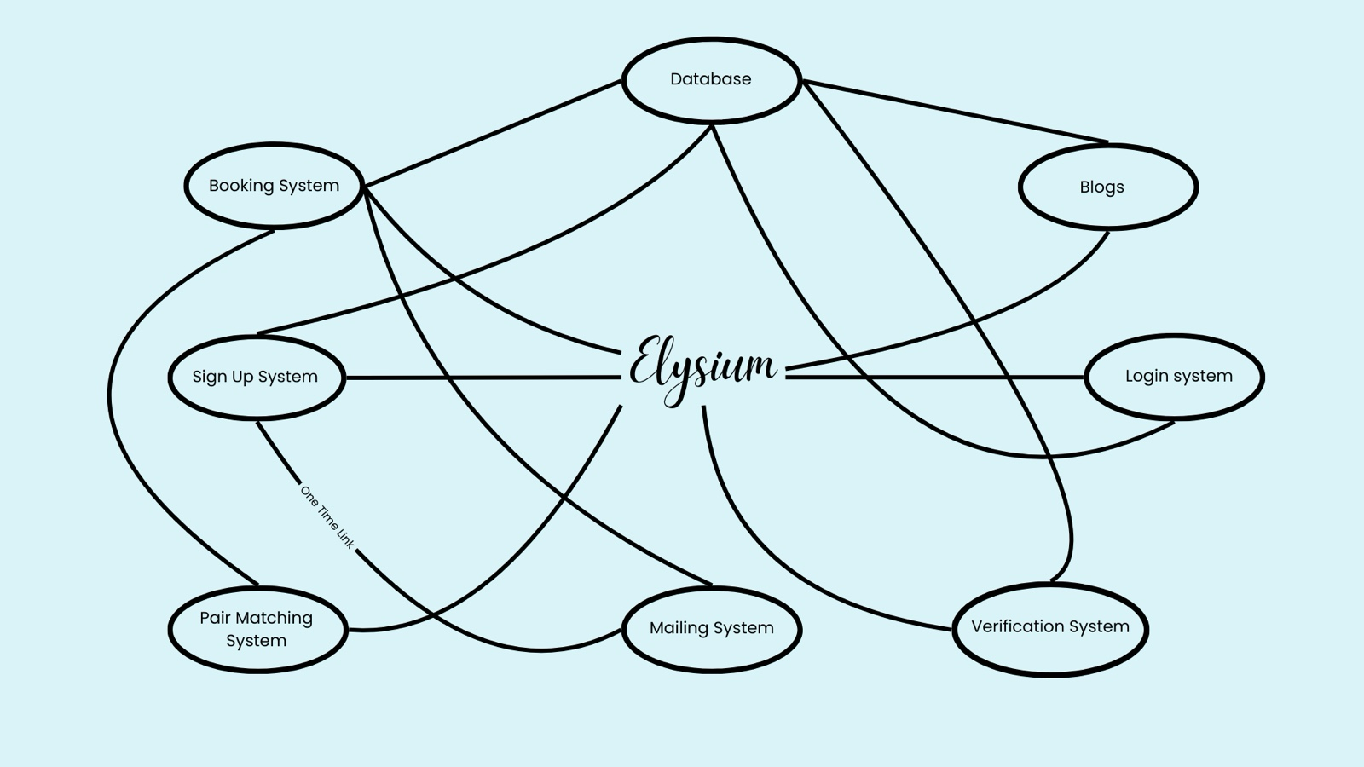

* **Login System:**

This system will securely handle the task of authenticating the users and redirecting them to their respective user landing pages based on the category selected.

* **Sign-Up System:**

This system will be used to allow users to register to the application, and validate their e-mails, by communicating with the mailing system.

* **Mailing System:**

The mailing system will be used to communicate with users, send notifications and send a One Time Link for e-mail verification during signup.

* **Booking System:**

This system will overlook all the bookings, including the court reservations, equipment, workshop booking and appointments with the ICS Counsellors.

* **Pair Matching and Allotting System:**

This system is the crux of this application, which will implement the pairing algorithm and the algorithm to allot the courts, such that fair play is ensured.

* **Verification System:**

This system will be used to verify the entry of the students that have been allotted the court which will be used for future allotments.

* **Content System:**

All the blogs and content posted by instructors and counsellors will be handled by this system.

## Human Interface Design

* + 1. **User Interface Designs**
       1. **Sign-Up Pages**

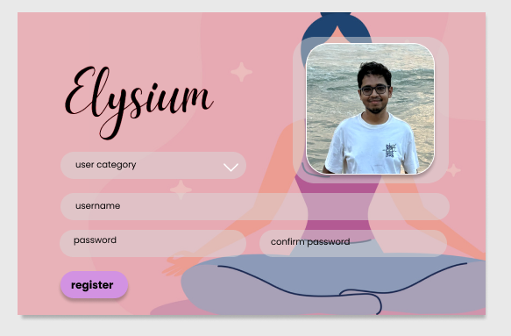

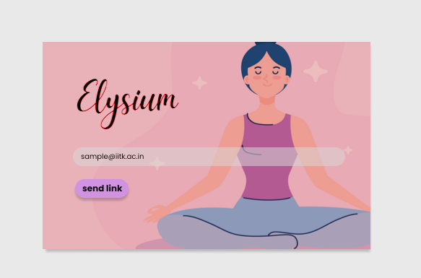

Sign-Up Pages, with e-mail verification and input fields for all relevant details.

* + - 1. **Login Page**

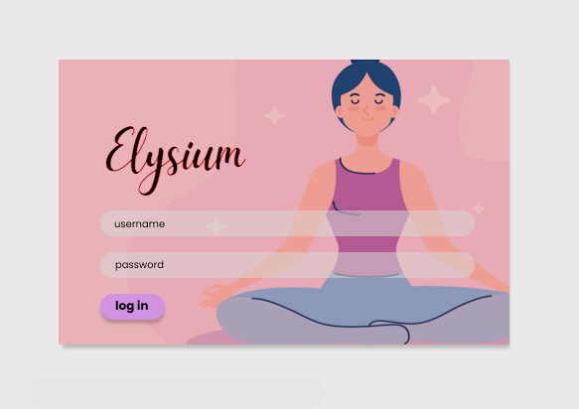

Login Page, with username and password as the required credentials for login.

* + - 1. **Landing Page for Normal Users**

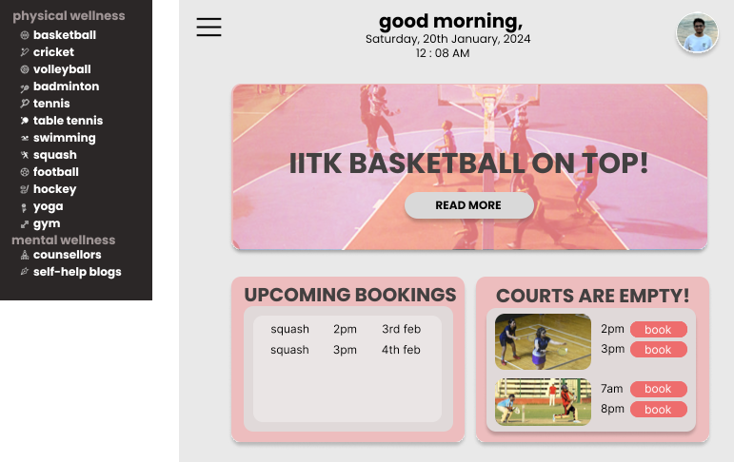

First landing page, with highlights shown for quick access, and a side navigation bar to access both the physical and mental wellness sections.

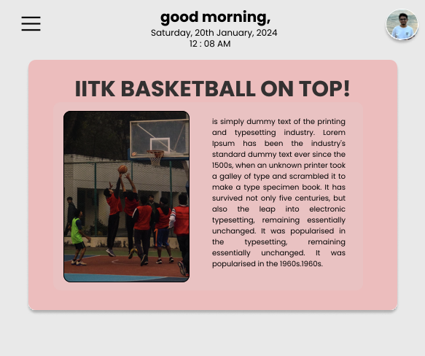

Popup, which gives more information related to the highlight displayed on the landing page.

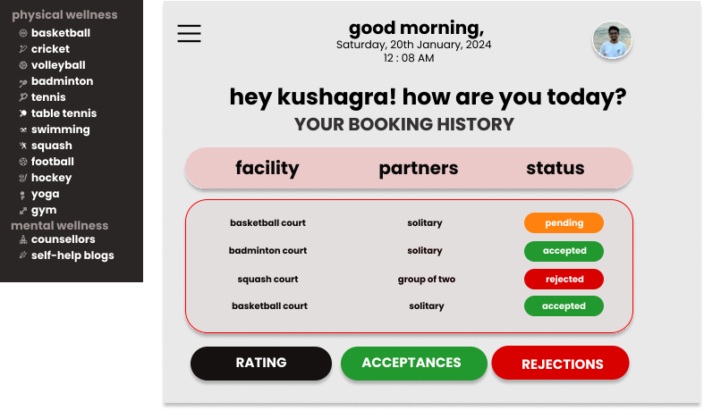

History, which opens when the profile picture is clicked. This page provides all the acceptance and rejections of bookings throughout the app for quick access.

* + - 1. **Sports Booking**

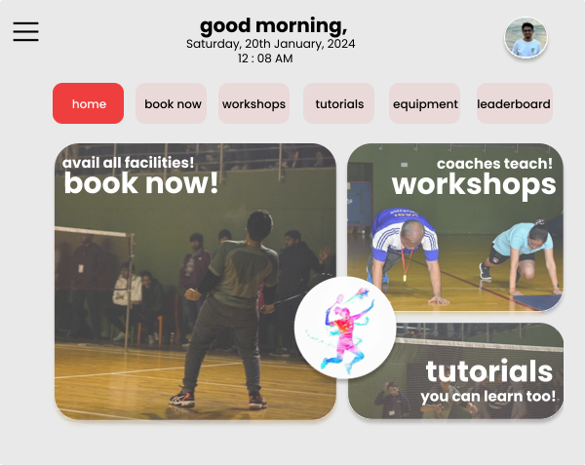

Sport Page, which appears when a sport is clicked on, using the side navigation bar. This page is the central hub for every sport related activity.

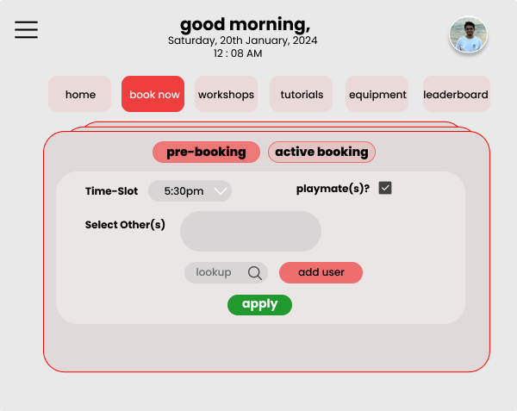

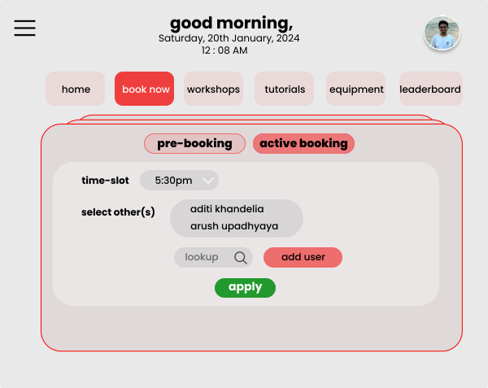

Booking Slots page, which has options to book for both pre-booking and active booking systems.

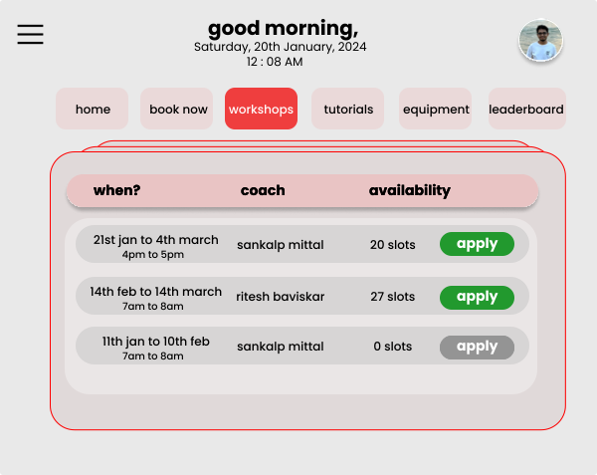

Workshops page, to apply for a slot in the workshops that will be posted by the coaches.

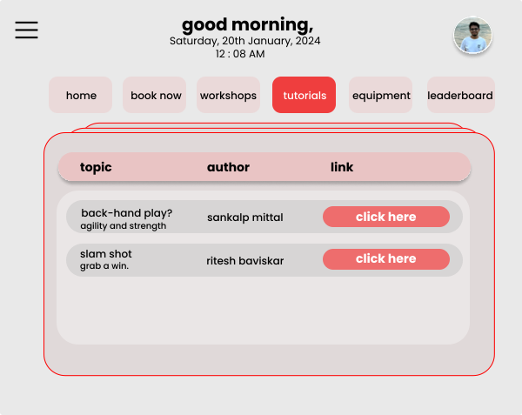

Tutorial page, which will contain tutorials of the game posted by the coaches.

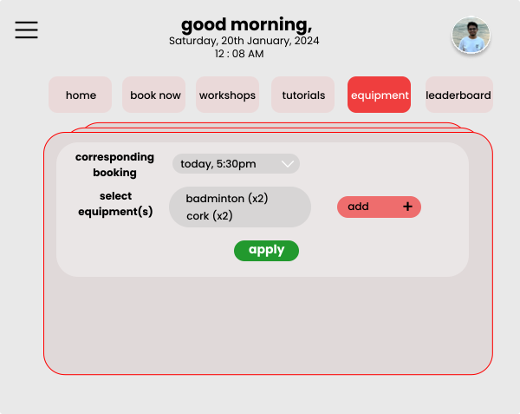

Equipments page, to book for equipment for the sport, with a valid slot booking ID.

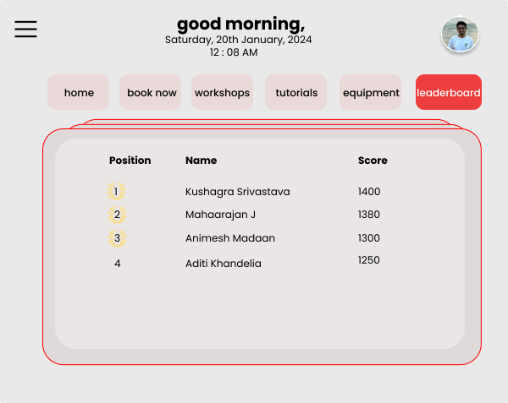

Leaderboard page, which contains ratings assigned to the players, using our algorithm.

* + - 1. **Swimming Pool/ Gym Membership**

*The UI Design for both the gym and the swimming pool facilities will be the same, here the UI for swimming pool has been depicted.

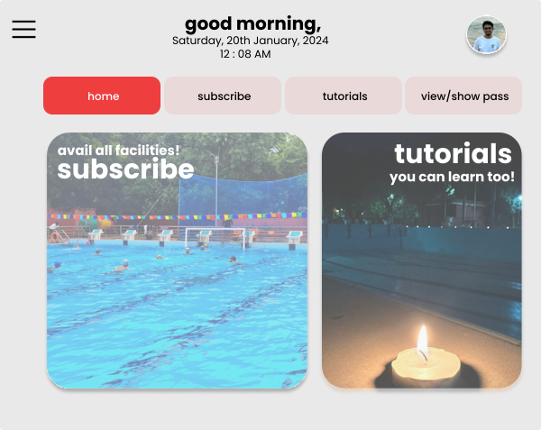

Landing page, for the pool facilities.

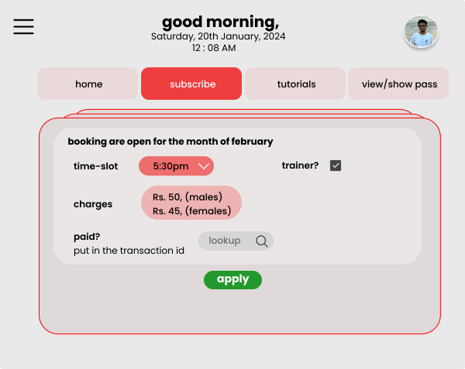

Subscription page for the swimming pool, for the current month along with the time slot.

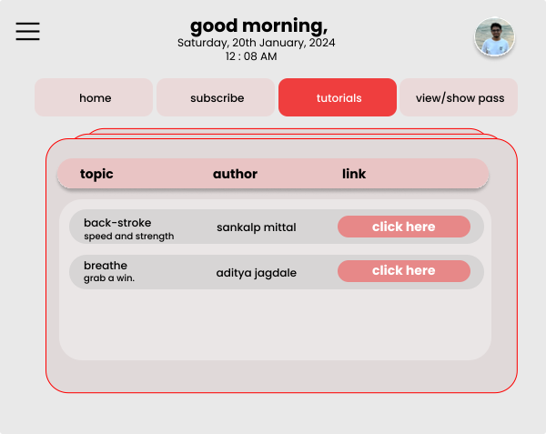

Tutorials, posted by the coaches to assist in the learning experience.

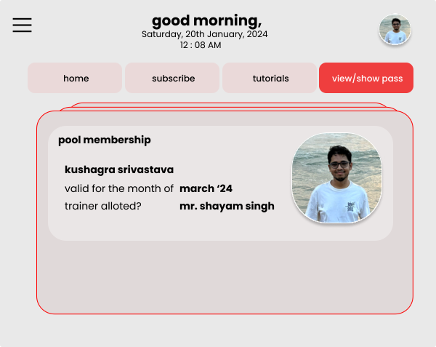

Automatically generated pass, for easier physical verification.

* + - 1. **Counsellor Booking**

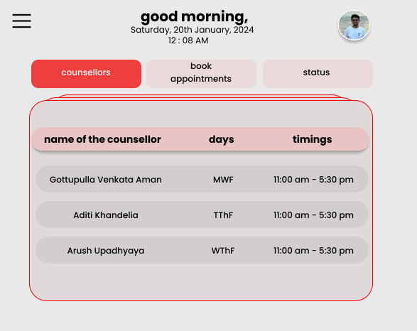

Counsellor’s directory, which lists out their availability.

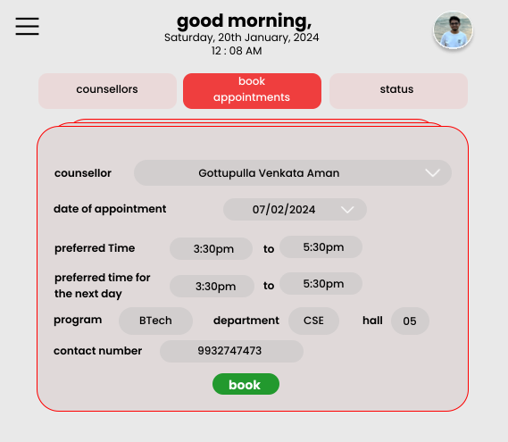

Page to book appointments with the counsellor, with all the relevant details as required by the Institute Counselling Service.

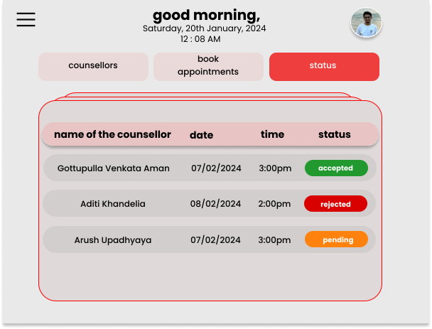

Status page, which provide access to acceptance and rejection updates for an appointment.

* + - 1. **Yoga Session Booking**

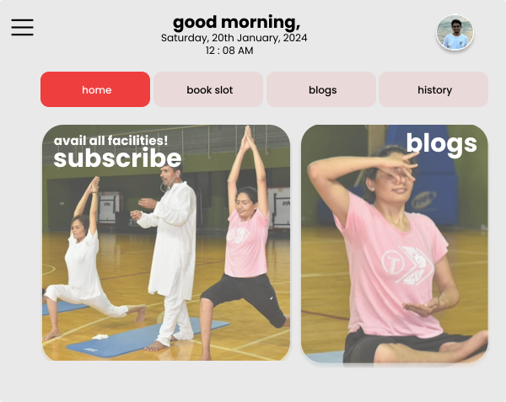

Landing Page for Yoga Sessions

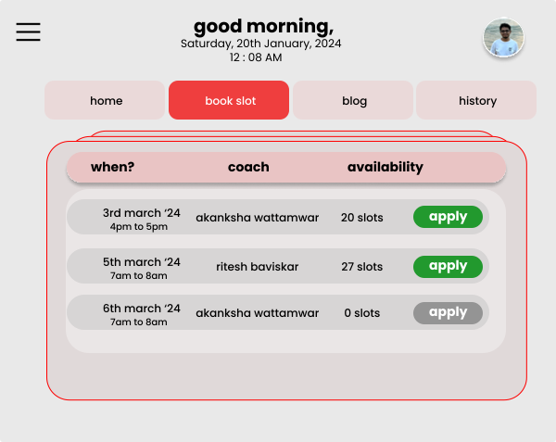

Booking a Yoga Session

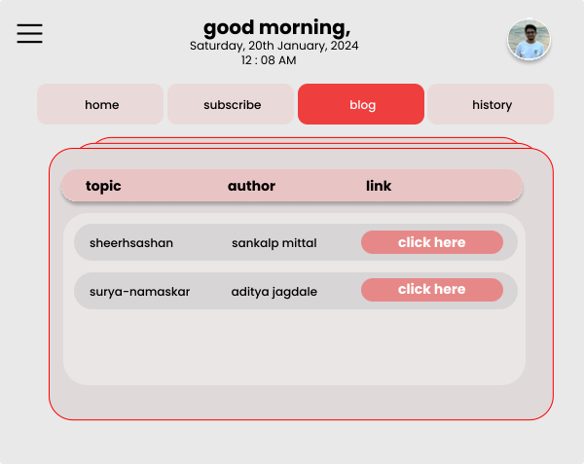

Blogs posted by yoga instructors can be accessed from this page.

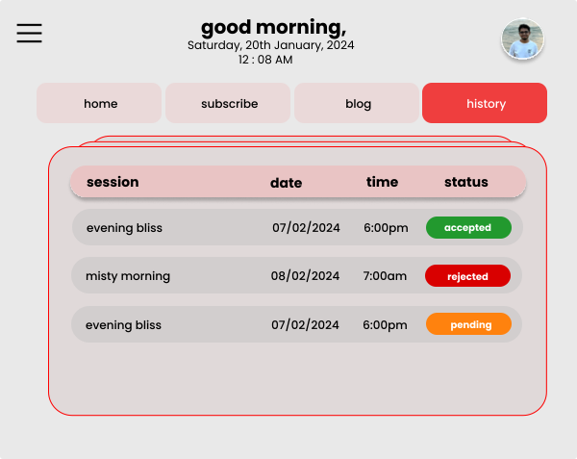

History of all booked, rejected, and pending yoga sessions will be visible here.

* + - 1. **Self Help Blogs**

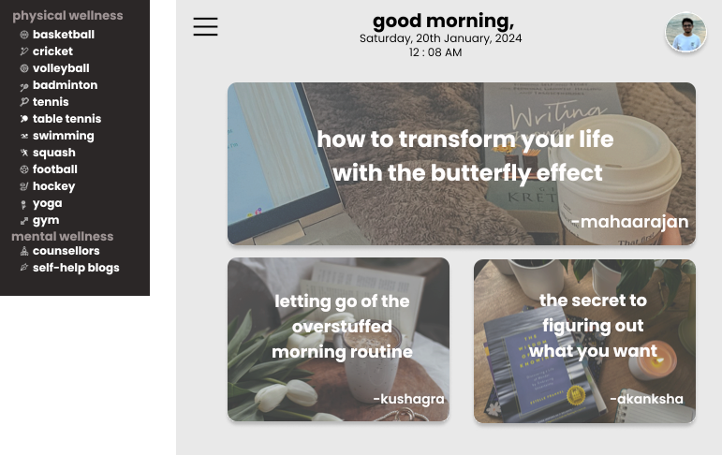

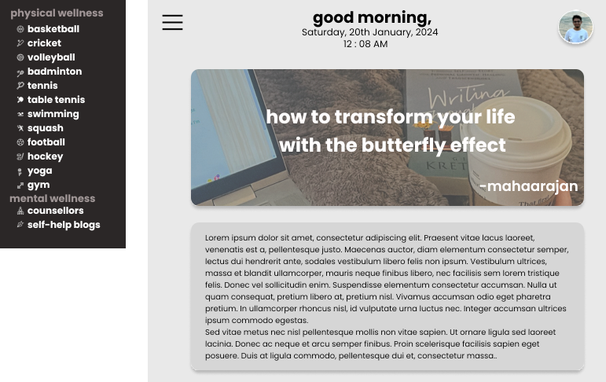

Self help blogs posted by counsellors

* + - 1. **Sports Coaches Dashboard**

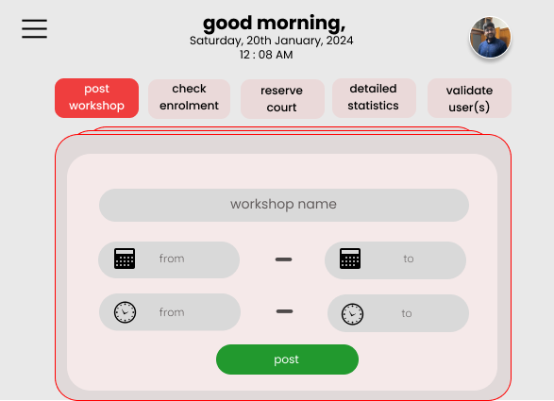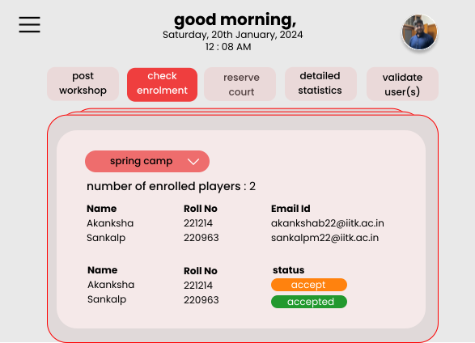

Workshops can be posted and managed by the coaches using their dashboard

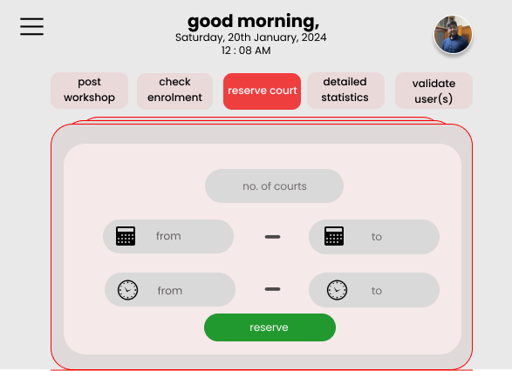

Slots on the court can be reserved for a given date and time period.

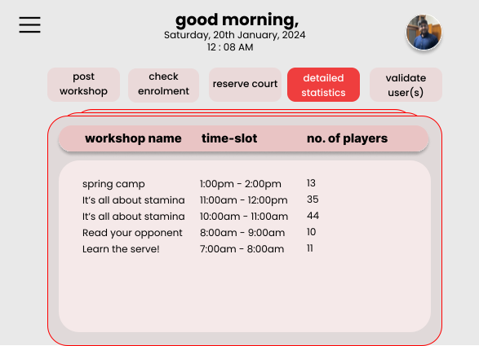

Statistics.

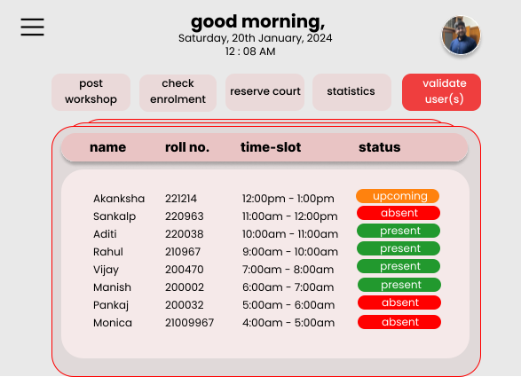

Validation of the users that have registered for a slot.

* + - 1. **Yoga Instructor’s Dashboard**

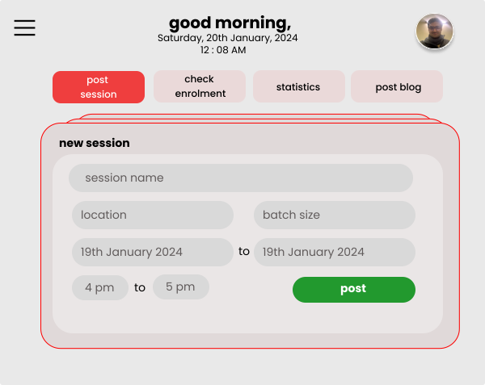

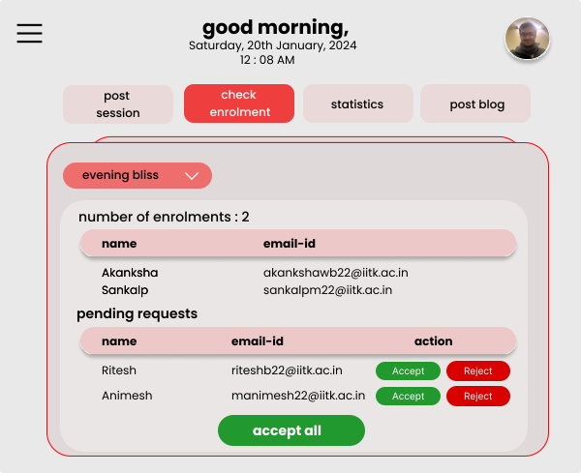

Workshops can be posted and managed by the coaches using their dashboard.

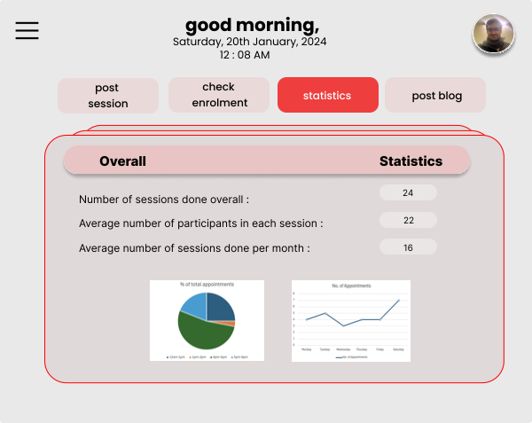

Statistics, related to the yoga sessions conducted till date.

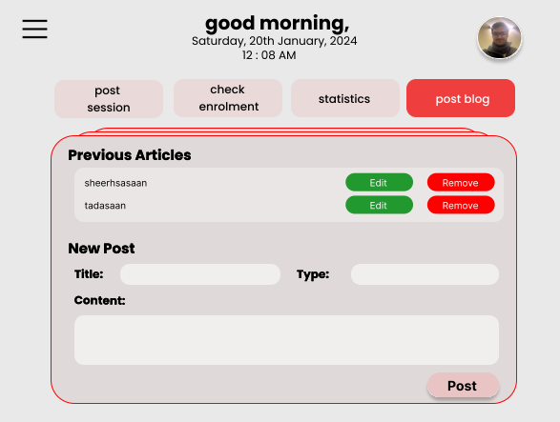

Yoga Instructors can post blogs.

* + - 1. **Swimming Pool/ Gym Instructor’s Dashboard**

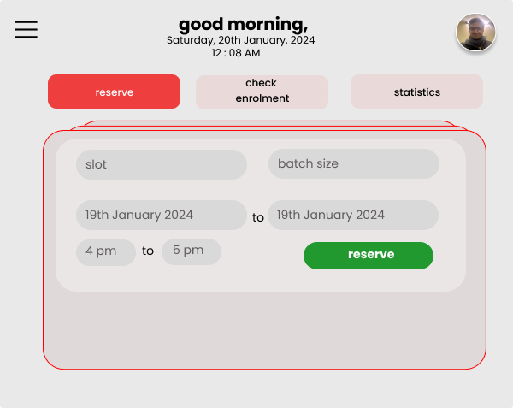

Reserve a slot in the pool or gym.

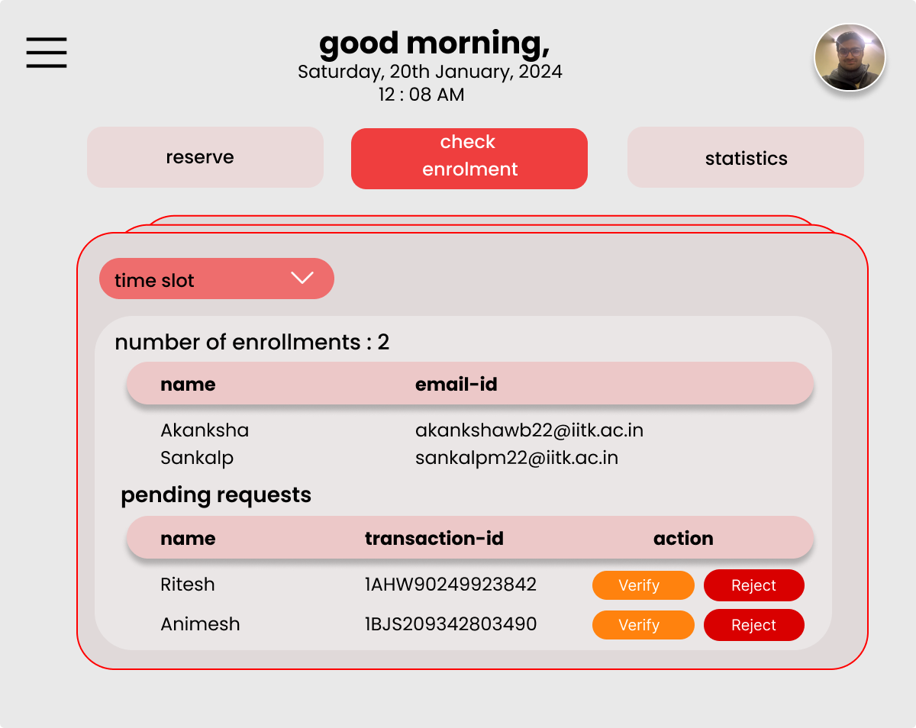

Check Enrolment for the pool, and verify users based on the transaction IDs.

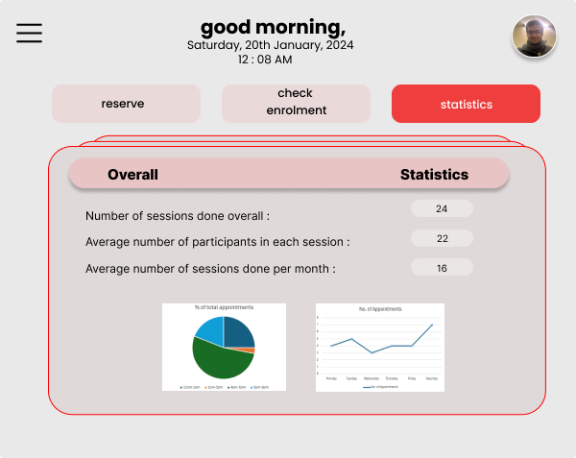

Statistics of the usage of the facilities till date, with graphs and pie-charts.

* + - 1. **Counsellor’s Dashboard**

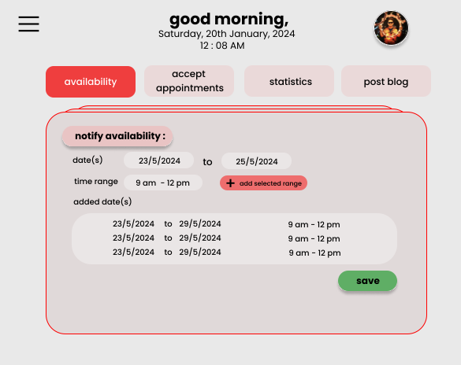

Counsellors can notify un-availability beforehand, so that students can book slots only when the counsellor is available.

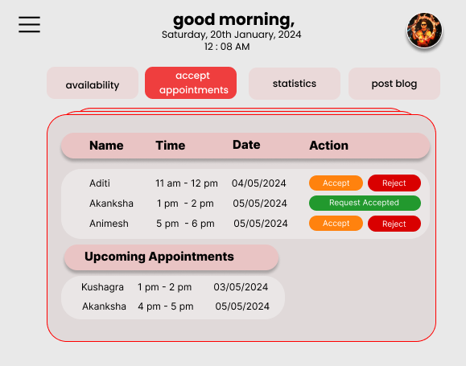

Counsellors can accept appointments and keep track of the upcoming appointments.

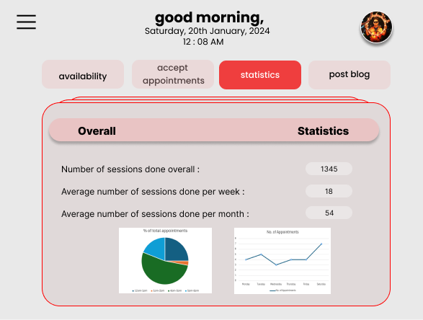

Statistics, relating the number of sessions held other relevant numbers.

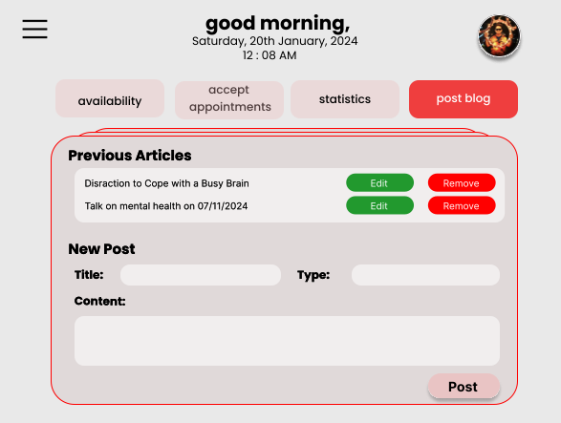

Counsellors can post self-help blogs for the campus junta to read and enhance their personal life.

# Architecture Design

**Model View Control Architecture**

We shall be using the Model view architecture pattern in our application as we will need to view and interact with a large variety of data in numerous ways such as making bookings, matching pairs, scheduling sessions, etc. MVC is also flexible and allows the application to expand and incorporate more features, if necessary, in the future.

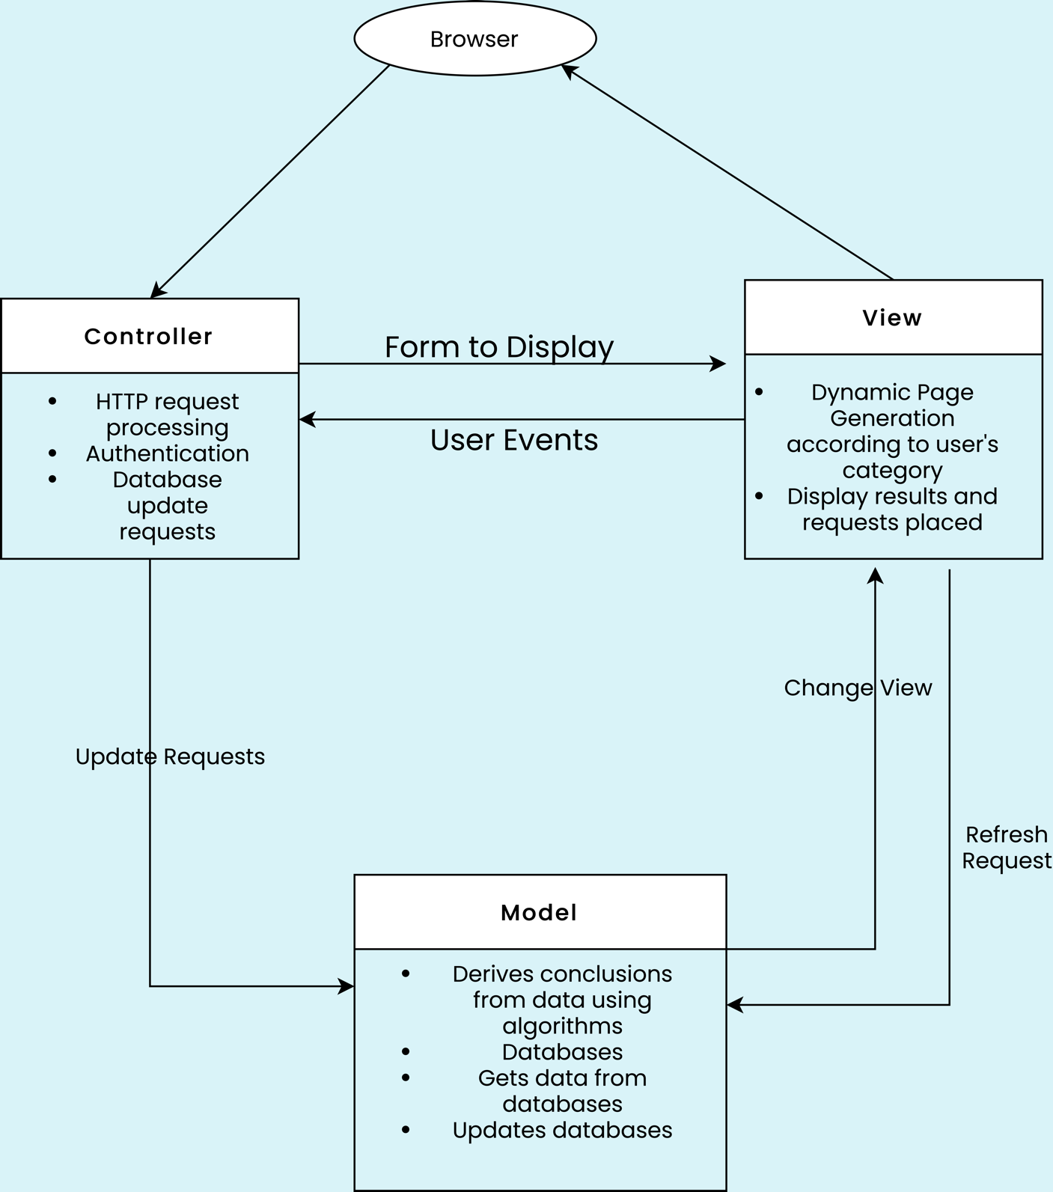

**Model :**

Many databases are to be made to implement the various use cases of our software. An exhaustive list of the same is given below. The model shall actively fetch and update the data present in these databases, as listed in the diagram below.

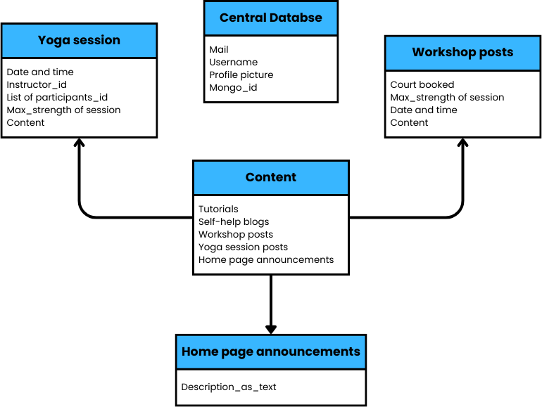

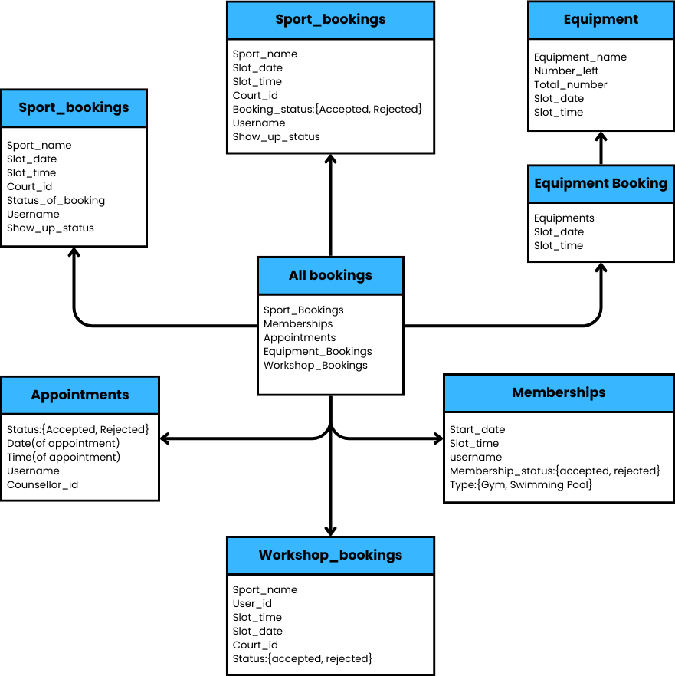

**Controller**

The controller shall interact between the View and the model, it will send requests for updates and make the software interactive with users. Its main parts would be:

* HTTP requests (Requests made when the user interacts with the software by clicking)
* Authorisation (Verification of login credentials with the existing database)

**View**

According to the category of the user and the functionality the user employs different views will be seen. These views (User Interfaces) can be broadly classified into the following:

* Counsellor dashboard
* Coach dashboard.
* Yoga instructor
* Gym/ swimming pool instructor
* Sign in pages.
* Landing pages.
* Sports and wellness booking pages.

The views actively refresh by using data from the databases mentioned above and provide an interface for the user to make use of the app functionalities.

# Object Oriented Design

## Use Case Diagrams

* + 1. **Sports Slot Booking**

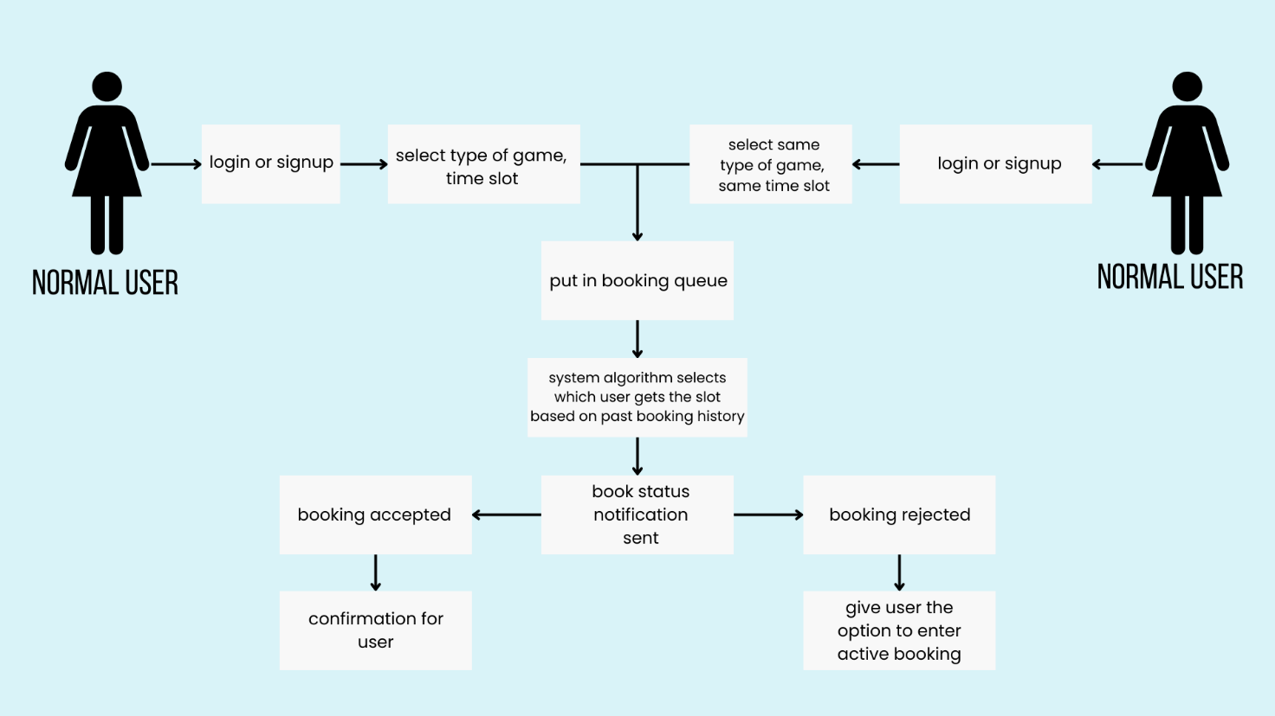

**Author** - This use case was written by Animesh Madaan and Arush Upadhyaya.

**Purpose** - To allow users to book sports courts and facilities and select which user gets the resource requested for in case of clash, taking into account users’ booking histories.

**Requirements** **Traceability** - This feature settles conflicts in reservations and assigns a booking priority according to a set of criteria derived from the user's past reservations.

**Priority** - This use case has a high priority since system users won't be able to reserve slots if the system malfunctions.

**Pre-conditions** -Users interested in booking a slot must pick the slots of availability.

**Post**-**conditions** - The users will get notified if they get a slot. And if they do not, they have the option to book a slot in “active” booking.

**Actors** - Actors in this use case are the students acting as the users.

* + 1. **Yoga Session**

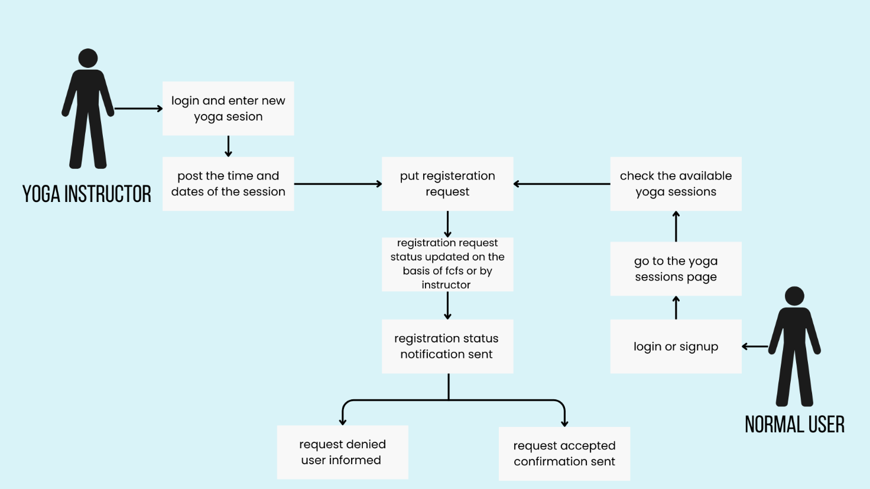

**Author** - This use case was written by Aditi Khandelia and Kushagra Srivastava.

**Purpose** - To allow yoga instructors to post about yoga sessions and allow the users to register for the same.

**Requirements Traceability** -To handle the announcements of upcoming yoga sessions and manage the same. To handle registration of these yoga sessions.

**Priority** - The priority of this use case is high. Mental wellness is an essential component of the system and yoga sessions are pivotal to the students’ mental and physical wellbeing.

**Preconditions** - The yoga instructors need to have a yoga instructor’s profile which will allow them to post about upcoming yoga sessions. The users will have a user profile that allows them to view upcoming sessions and register for the same. Users will also be sent a notification when yoga instructor posts about a new workshop.

**Post conditions** - The users will be sent a notification if their request to register in a session gets accepted. In case of acceptance, the session will appear in the schedule of the user. The number of people registered for the session will also be reflected on the instructor’s dashboard.

**Actors** - Yoga instructors for posting about sessions and student users for registering for the same.

**Exceptions** - There are no exceptions in this use case.

* + 1. **ICS Appointment**

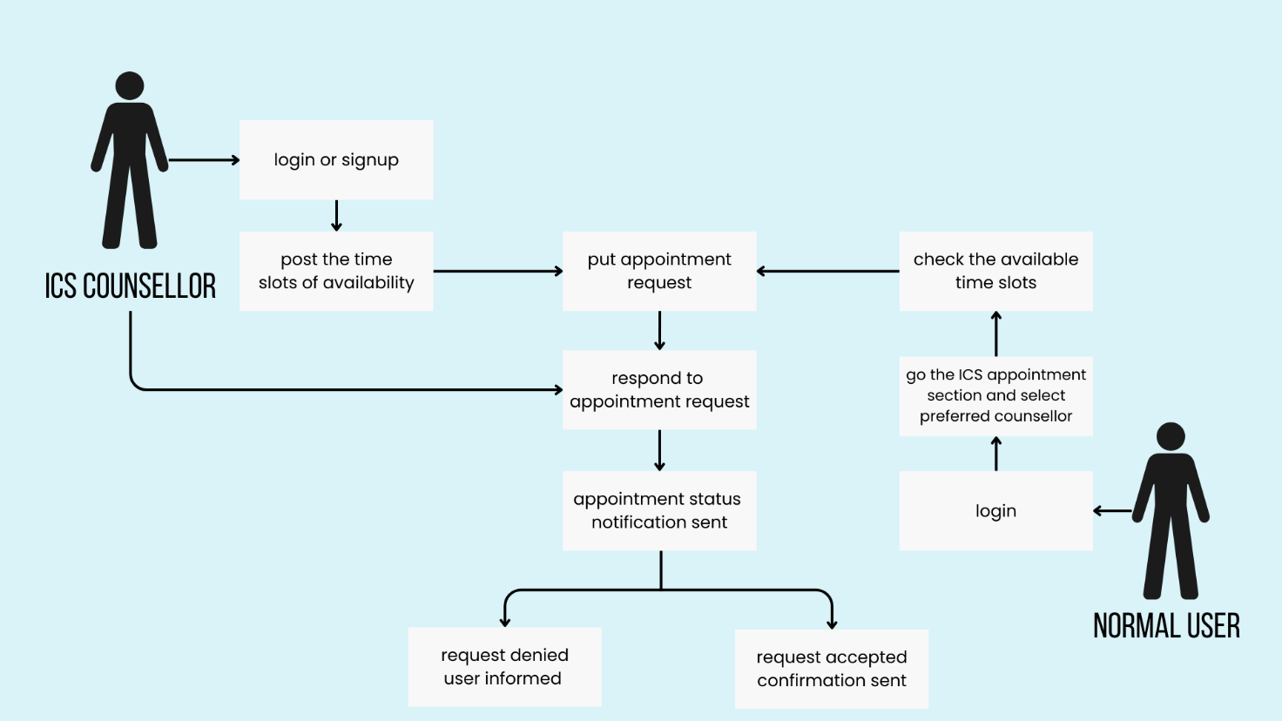

**Author** - This use case was written by Animesh Madaan.

**Purpose** - Functionality for users to book appointments with therapists of the Institute Counselling Service.

**Requirements Traceability** -In order to handle appointments, such as accepting reservations and rescheduling appointments, counsellors need to have a profile with administrative rights. To schedule sessions, the user also must have an account.

**Priority** - At its core, this app is about making mental health services easily accessible. It is imperative that this use case be executed flawlessly. These hiccups seriously impair our main goal. Therefore, the priority of this functionality is high.

**Preconditions** - The therapists must indicate in-person when they are available and suggest a time for future appointment scheduling.

**Post conditions** - The user should be notified after approval of their booking by the therapist.

**Actors** - Counsellors for managing bookings and students for booking sessions.

* + 1. **Gym/Pool Membership**

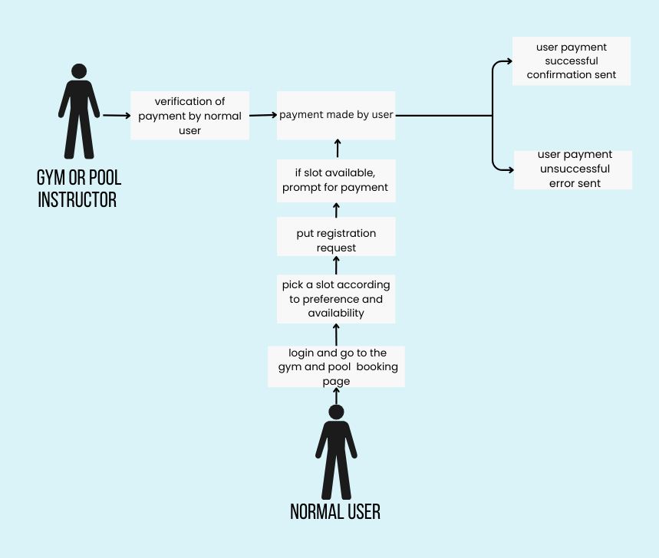

**Author** - This use case was written by Aditi Khandelia and Arush Upadhyaya.

**Purpose** - To allow users to apply for monthly/ yearly gym and pool memberships.

**Requirements Traceability** -This use case is required by the users who want to avail the gym or swimming facilities for a specific timeframe.

**Priority** - The priority of this use case is medium. This is because the primary purpose of our software is to ensure easy access to the physical wellness and mental wellness facilities on campus and most of them remain functional even if this use case fails.

**Preconditions** - A schedule displaying the available time slots for availing the gym and pool facilities on campus. The user should have a profile from where they can apply for membership.

**Post conditions** - The users will be sent a notification if their request for membership is accepted. Payments will be made through SBI icollect upon receiving the notification by the user. This will lead to confirmation of membership.

**Actors** - Users to apply for gym and pool memberships.

**Exceptions** - There are no exceptions in this use case.

* + 1. **Pair Matching**

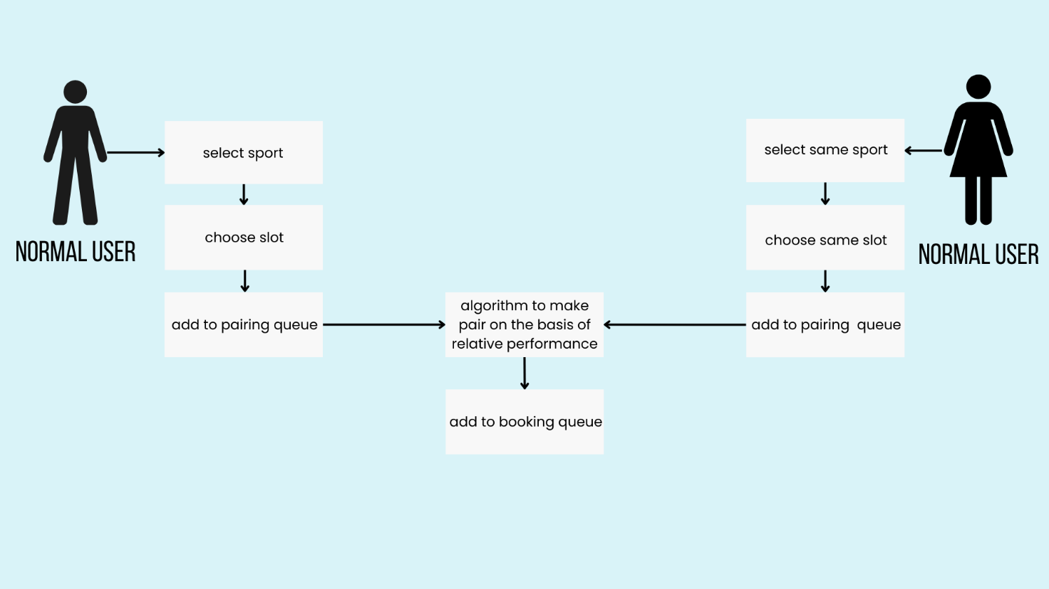

**Author** -This use case was written by Maharajan J and Sankalp Mittal.

**Purpose** - To pair individuals who are looking for playmates.

**Requirements Traceability** -Many users might not have a partner to play the game with, so this feature allows them to find playmates and enjoy the game.

**Priority** - The priority of this use case is medium as it is one of the additional features of this application and any problems in this use case will decrease the scope of this application.

**Preconditions** - The selection of sport and the preferred timeslot(s) must be completed before the pair matching begins.

**Post conditions** - The user can check after the booking period is over whether they have been allotted a pair and a court and will get the details of their partner and their allotted timeslot.

**Actors** - The players who need a playmate will be the ones triggering this use case.

**Exceptions** - If there are odd number of people looking for a pair one person will not be a part of any pair and will not be included in the slot allotment algorithm.

**Includes** - Use Case 3.1.1

* + 1. **Sports Workshop Registration**

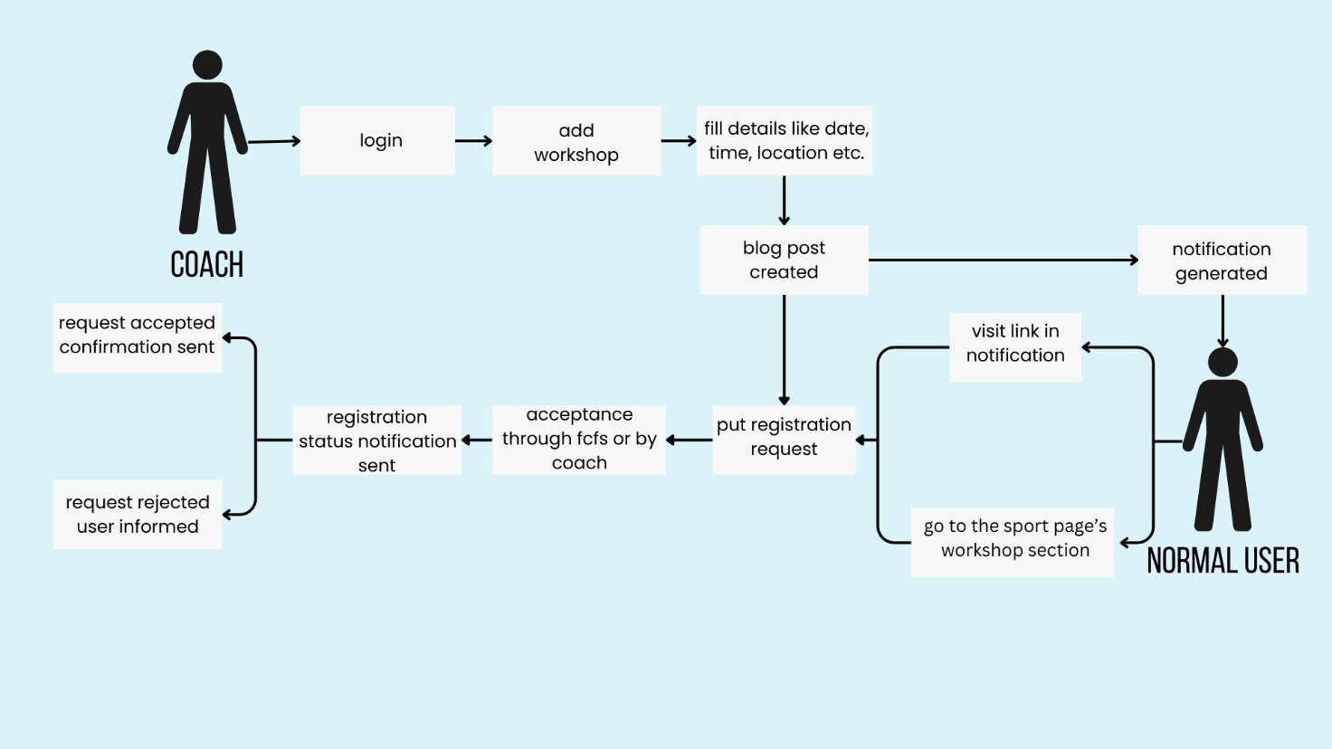

**Author** - This use case was written by Gottupulla Venkata Aman and Ritesh Baviskar.

**Purpose** -To inform users about upcoming workshops and open registration.

**Requirements Traceability** -The coaches and counsellors will have access to a common database which they will update regarding workshops and events within a certain timeframe. Also, coaches and counsellors and students will have access to the app which will notify them regarding upcoming sessions.

**Priority** - The priority of this use case is medium. The app will still retain its main functionality even if this use case fails.

**Preconditions -** The coaches and counsellors should update the database as and when required.

**Post conditions** - The users have the sessions and workshops in their upcoming schedule and all users will be notified.

**Actors -** Coaches and counsellors for scheduling sessions and students for booking sessions.

**Exceptions -** Users who have opted out of the notifications will not be notified.

* + 1. **Verify Player**

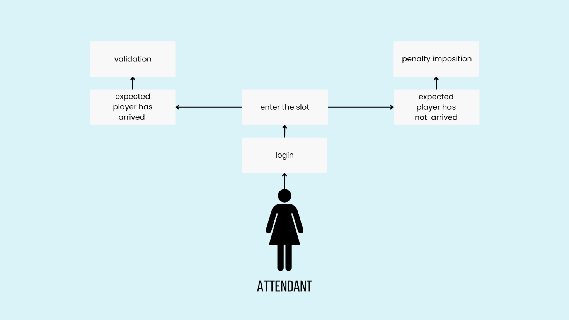

**Author** - This use case was written by Aditya Jagdale and Akanksha Wattamwar.

**Purpose** - To ensure the timely entry of users in accordance with their booked schedule and validate availability of courts.

**Requirements Traceability -** The staff must have signed up on their respective portal as an admin.

**Priority -** The priority of this use case is medium. The application will still be complete without it.

**Preconditions** - Require users to present their respective institute ID cards upon arrival.

**Post conditions** -

* Ensure user validation when the user arrives at the respective booked location punctually.
* If a user fails to arrive on time, impose a penalty, and subsequently, after a designated period, send a notification indicating that the current time slot is now available.
* If a user arrives before the designated period, adjust and reduce the imposed penalty accordingly.

**Actors** -Actors in this use case are users and staff.

**Exception** - Under the coach's order or request, whereby a booked slot can be allocated to the coach's designated person.

## Class Diagrams

1. 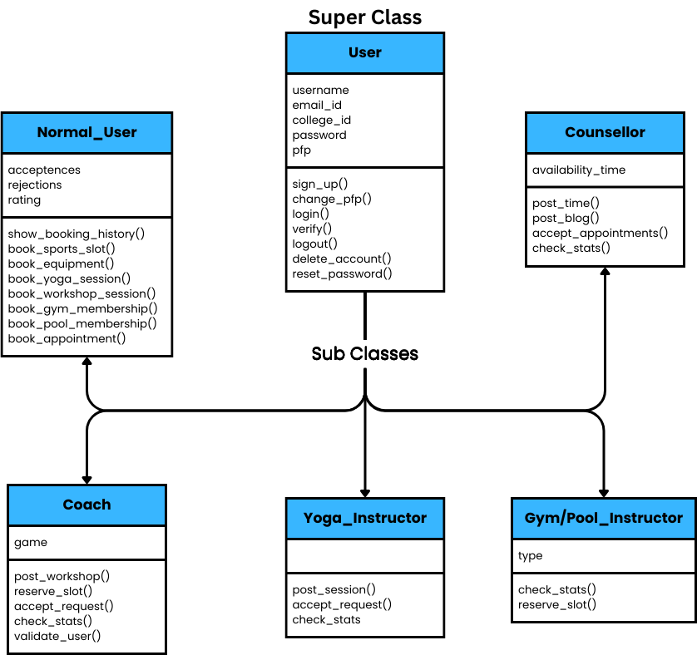**Class Diagram 1**
2. 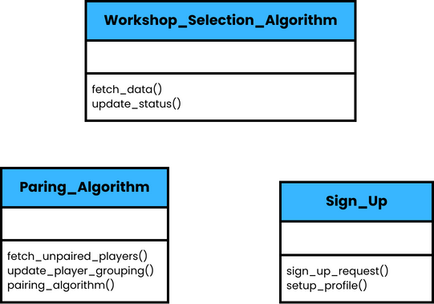**Class Diagram 2**
3. **Class Diagram 3**

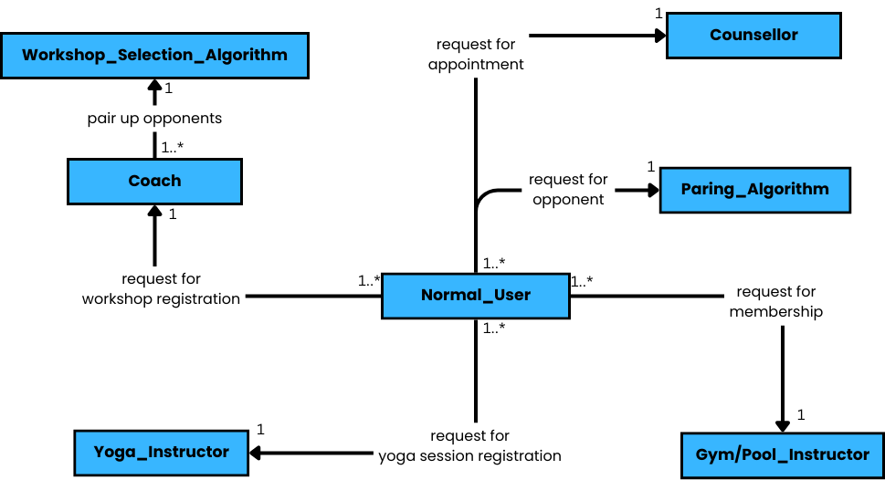

1. **Class Diagram 4**

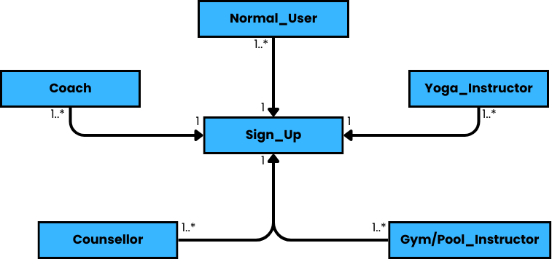

### Sign_up Class

* + **Methods**
    1. **send_verificaition_link() :** takes user data as argument and mails the one-click verification link to them.
    2. **create_profile() :** takes user data as inputcreates a profile for the user.

### User Class

* + **Attributes**
    1. **username :** the full name of the user
    2. **email_id :** the email id of the user
    3. **college_id :** roll no. for students and id number for instructors
    4. **password :** password for login
    5. **pfp :** profile pic of the user
  + **Methods**
    1. **sign_up_request() :** takes user data as argument and request for signing up
    2. **setup_profile() :** sets up the profile of the user in the database
    3. **login() :** takes username and password as argument and logs in the user
    4. **logout() :** logs out the user
    5. **change_pfp() :** takes new picture as argument and sets it as the new profile pic
    6. **delete_account() :** deletes account of the user
    7. **reset_password() :** **takes old and new password as the arguments and resets the password.

### Normal User Class

* + **Attributes**
    1. **acceptances :** number of times the booking of the user is accepted
    2. **rejections :** the number of times the booking of the user is rejected
    3. **ratings :** ratings of the user in various sports
  + **Methods**
    1. **booking_history() :** returns the list of past bookings of the user
    2. **book_sport_slot() :** takes time slot, sport and partners as arguments and request for a booking
    3. **book_equipment() :** takes a booked slot id and names of equipments as arguments and requests for booking of equipment
    4. **book_yoga_session() :** takes the yoga session id as argument and requests for a booking for yoga session
    5. **book_workshop_session() :** takes workshop id as argument and requests for a booking in the same
    6. **book_gym_membership() :** takes time slot, month and transaction id as arguments and requests for gym membership
    7. **book_pool_membership() :** takes time slot, month and transaction id as arguments and requests for swimming pool membership
    8. **book_appointment() :** takes counsellor id, time slot and date as arguments and request for appointment with ICS counsellor

### Coach Class

* + **Attributes**
    1. **game :** name of the game
  + **Methods**
    1. **post_workshop() :** takes content, time slot, date and size of the workshop as arguments and books a workshop in the database
    2. **reserve_slot() :** takes the time slot and date as arguments and reserves the court for team practice
    3. **accept_request() :** takes workshop id and user id as arguments and accepts their request
    4. **check_stats() :** takes the name of sport as argument and returns the statistics about the previous bookings
    5. **validate_user() :** takes booking id and user id as arguments and marks the user present

### Yoga_Instructor Class

* + **Methods**
    1. **post_session() :** takes time slot, date, content and size of the session as arguments and books for the session.
    2. **accept_request() :** takes session id and user id as arguments and accepts the user’s request for the session
    3. **check_stats :** returns the statistics about the previous bookings

### Gym/Pool_Instructor Class

* + **Attributes**
    1. **type :** returns the statistics about the previous bookings
  + **Methods**
    1. **check_stats() :** returns the statistics about the previous bookings
    2. **reserve_slot() :** takes the time slot and date as arguments and reserves the court for team practice

### Counsellor Class

* + **Attributes**
    1. **availability_time :** time slots when the counsellor is available for session
  + **Methods**
    1. **post_time() :** takes time as argument and updates time of availability
    2. **post_blog() :** takes content as argument and posts a blog on the website
    3. **accept_appointments() :** takes booking id as argument and accepts the appointment
    4. **check_stats() :** returns the statistics about the previous bookings

### Workshop_Selection_Algorithm Class

* + **Methods**
    1. **fetch_data() :** fetches all the documents of registration requests for a workshop
    2. **update_status() :** after deciding the acceptance or rejection of request as per fcfs, the documents in database are updated

### Pairing_Algorithm Class

* + **Methods**
    1. **fetch_unpaired_players() :** fetches all the documents of booking attempts for players who are looking for playmates
    2. **update_player_grouping() :** after pairing people, the corresponding documents are updated with partner names
    3. **pairing_algorithm() :** pairs people on the basis of their performance in the particular sport

## Sequence Diagrams

* + 1. **Sign-up**

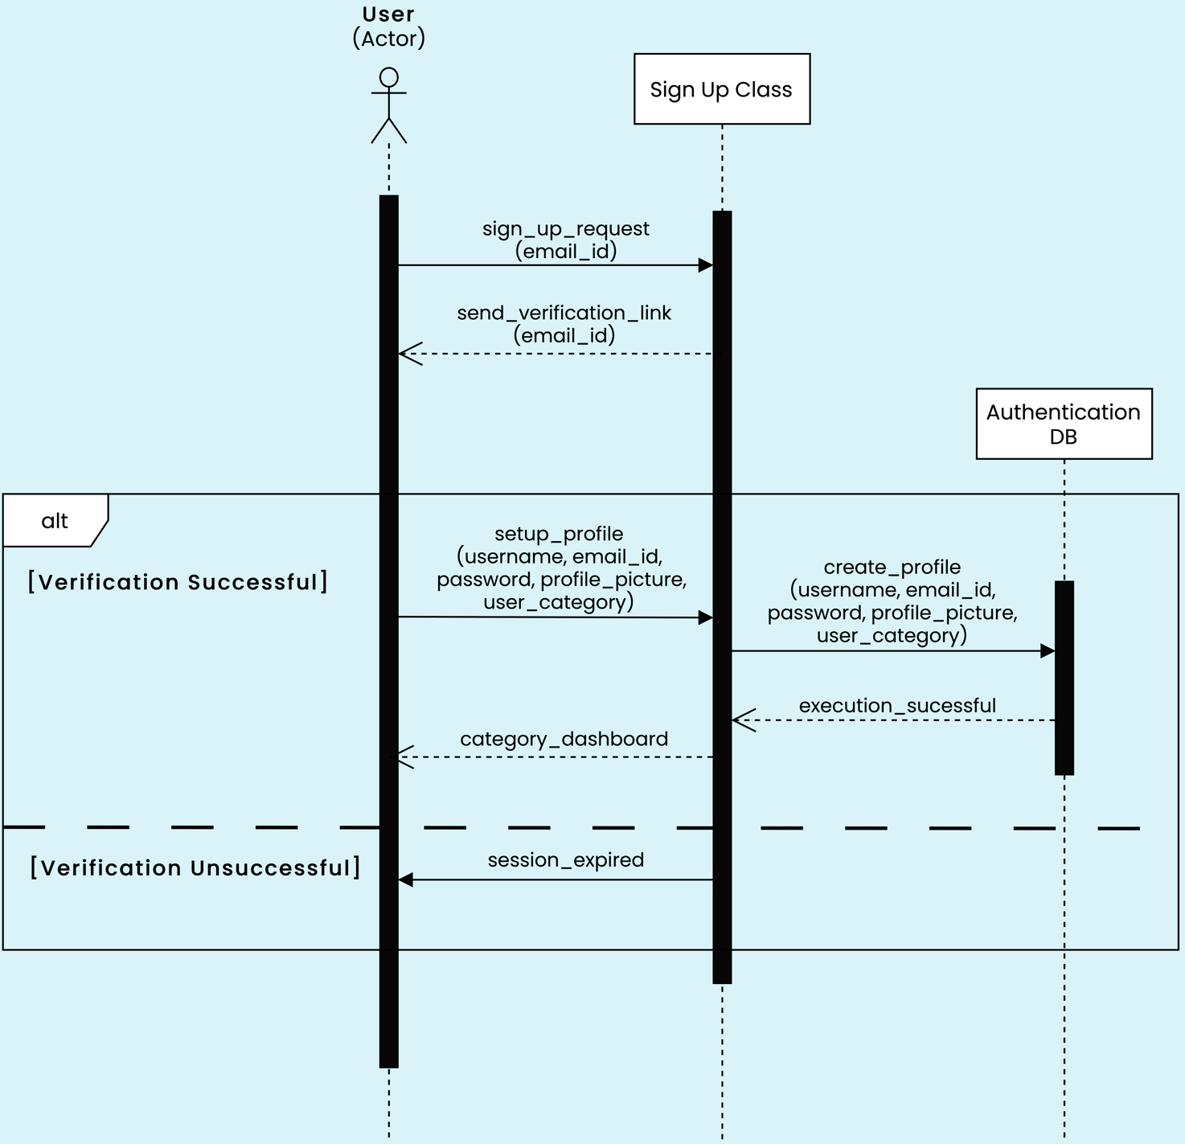

* + 1. **Login**

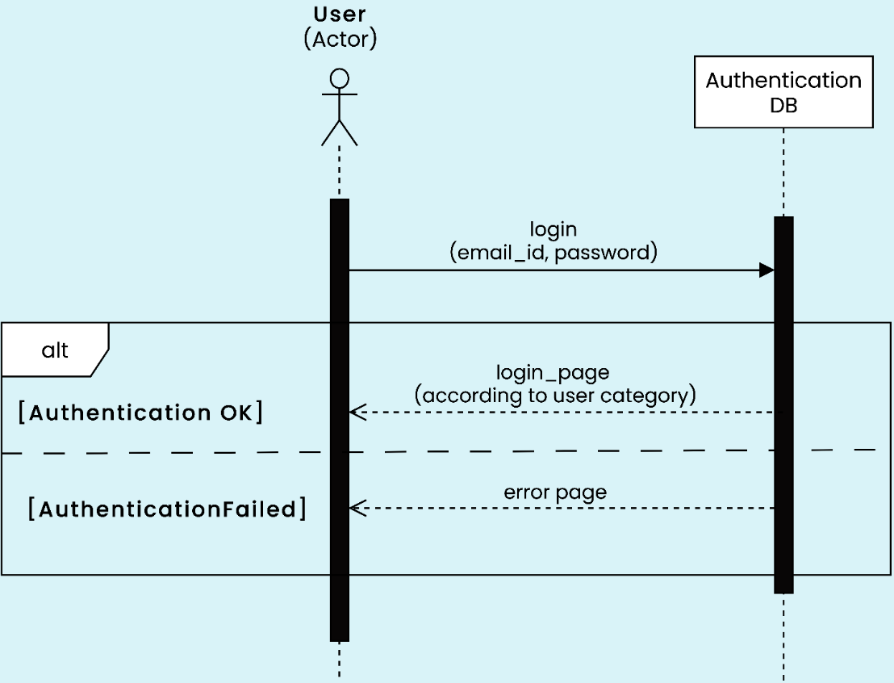

* + 1. **Attendant Verification**

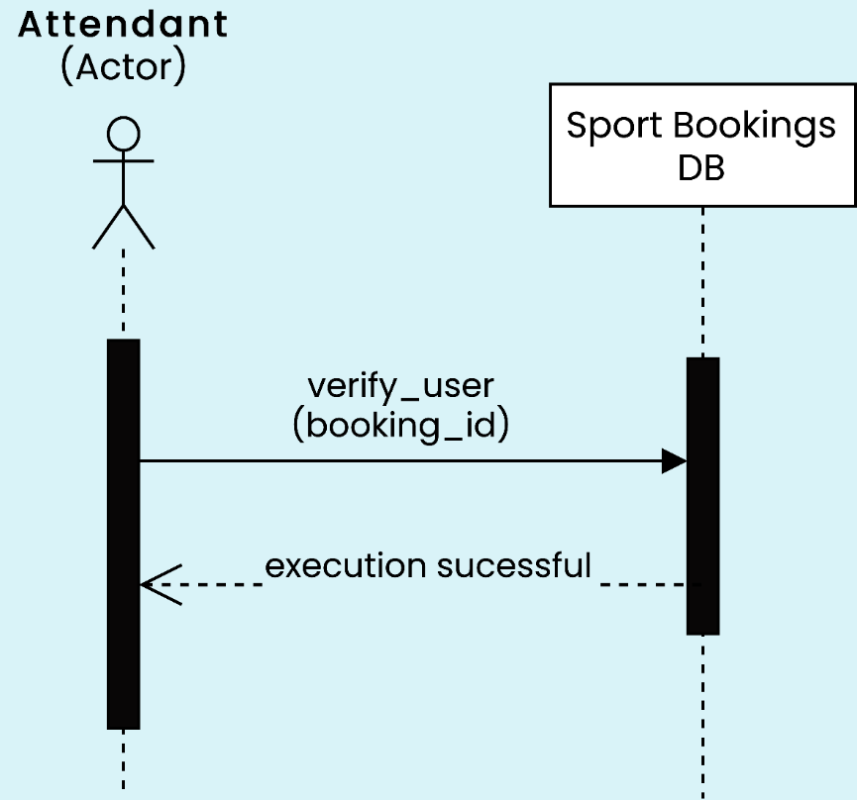

* + 1. **Posting Blogs by ICS counsellor**

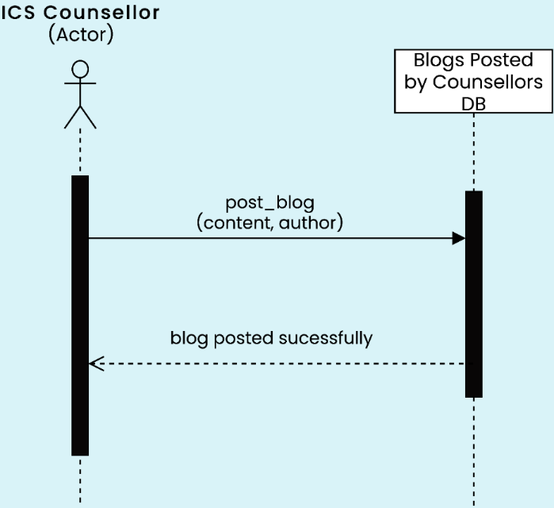

* + 1. **ICS Counsellor Appointment**

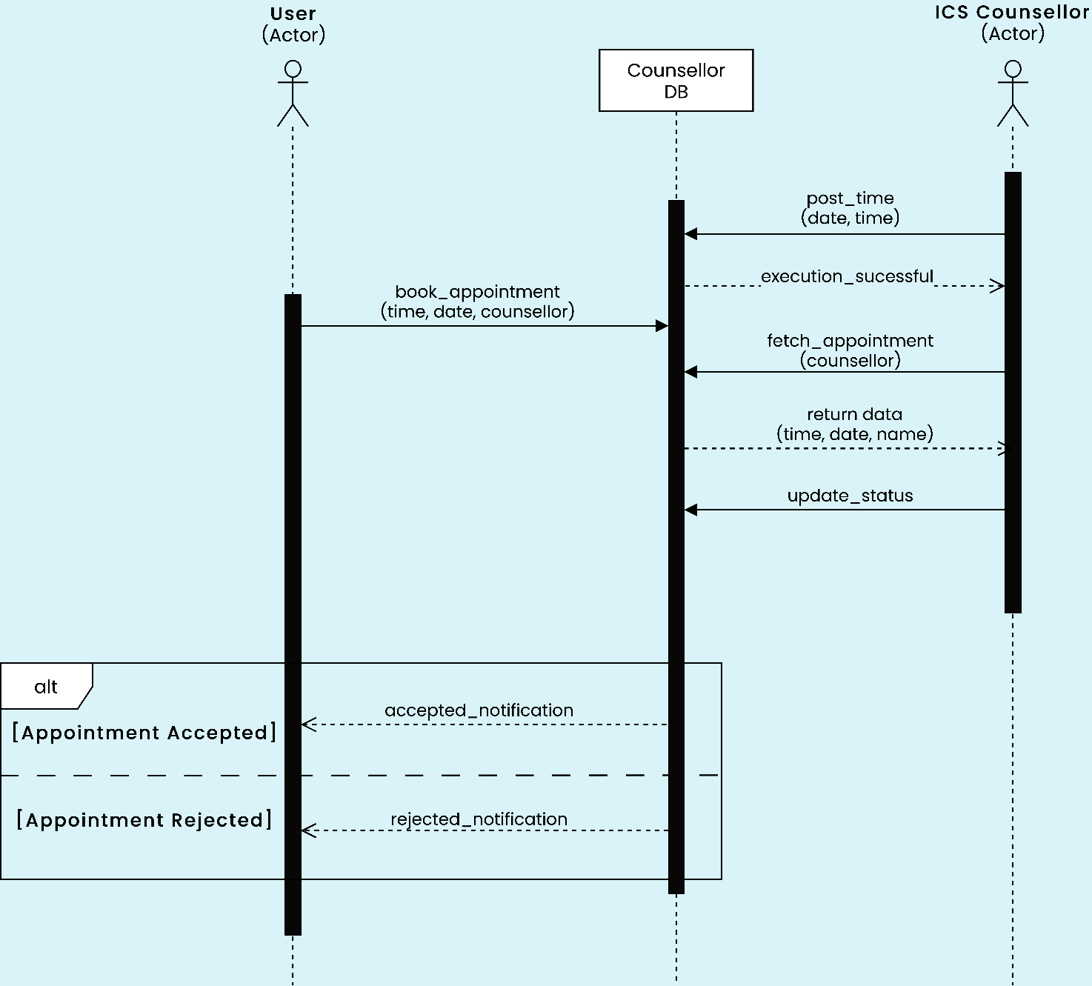

* + 1. **Gym/Pool Membership Application**

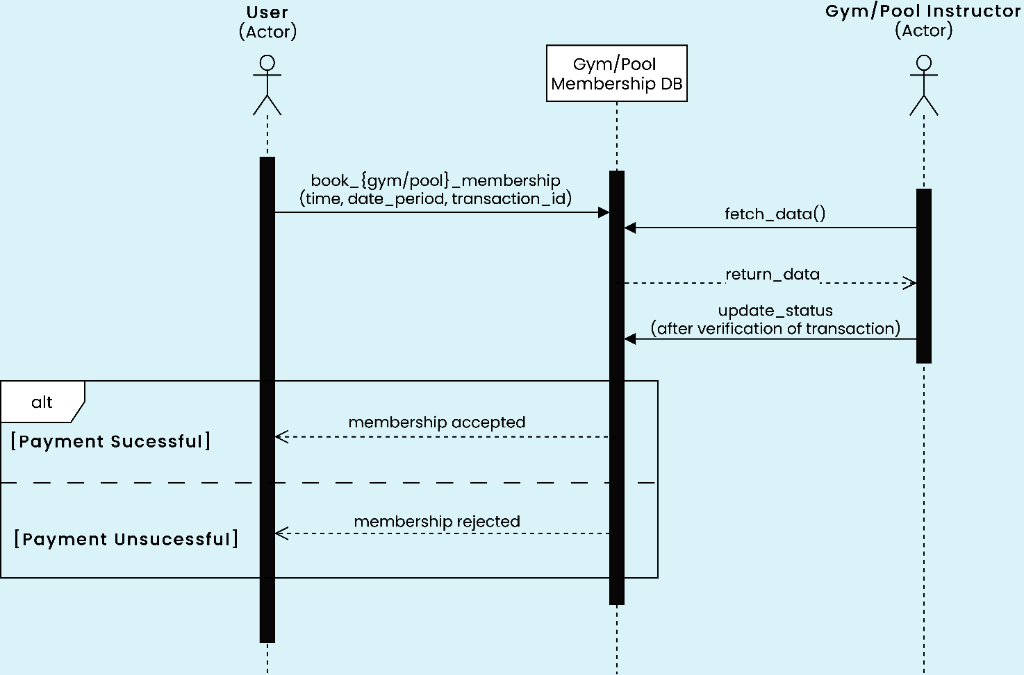

* + 1. **Pairing of Players for Sports Bookings**

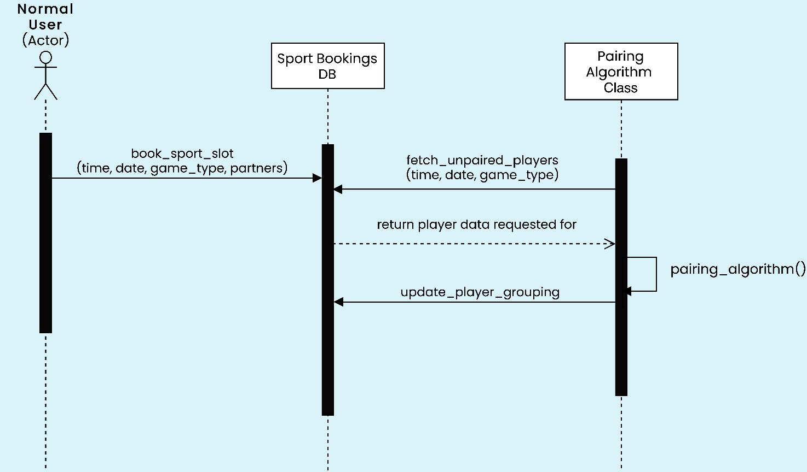

* + 1. 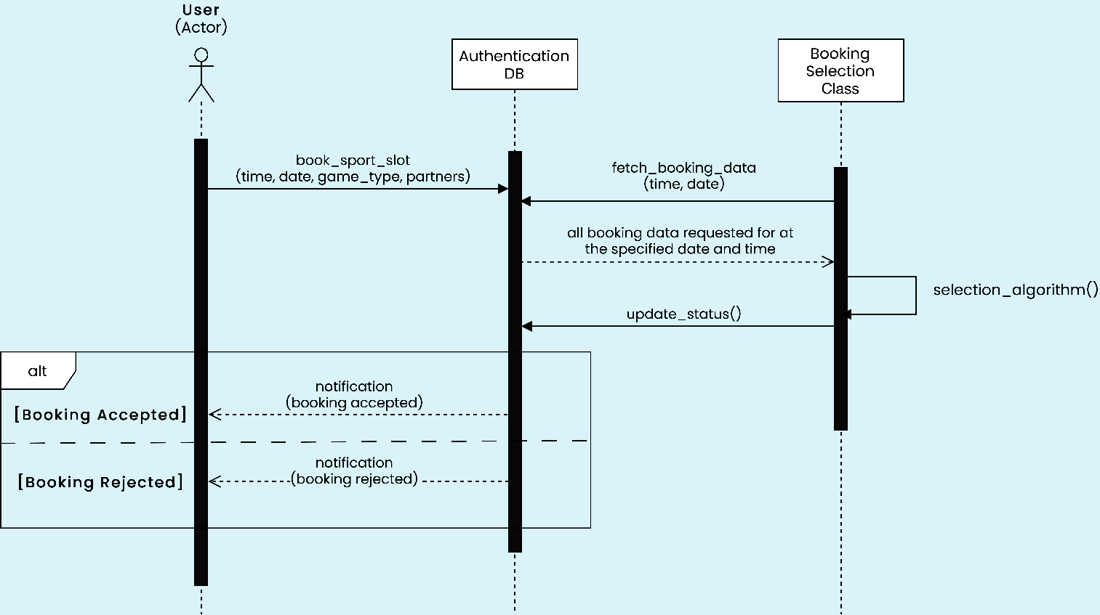**Sports Booking**
    2. **Workshop**

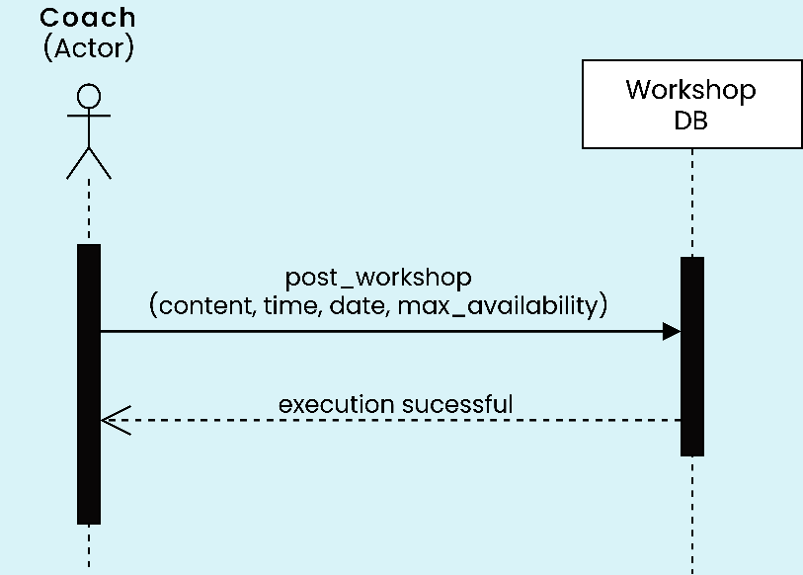

* + 1. 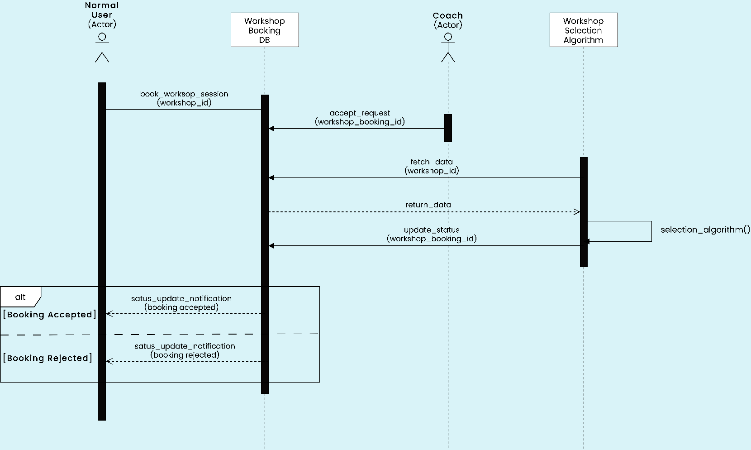**Workshop Booking**
    2. **Yoga Session**

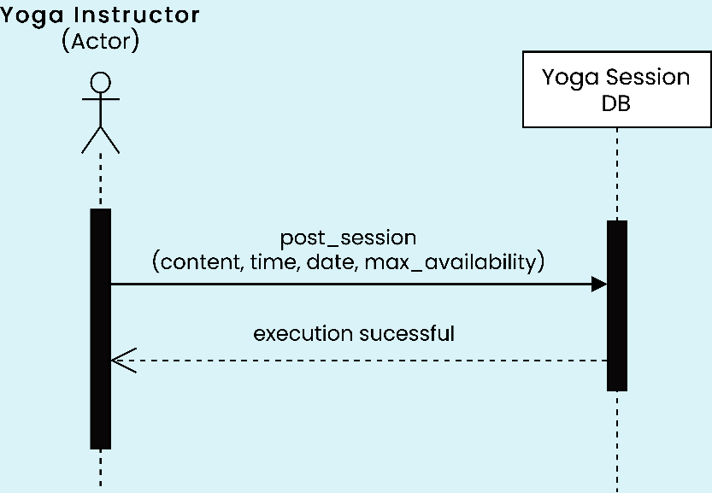

## State Diagrams

* + 1. **Login and Dashboard**

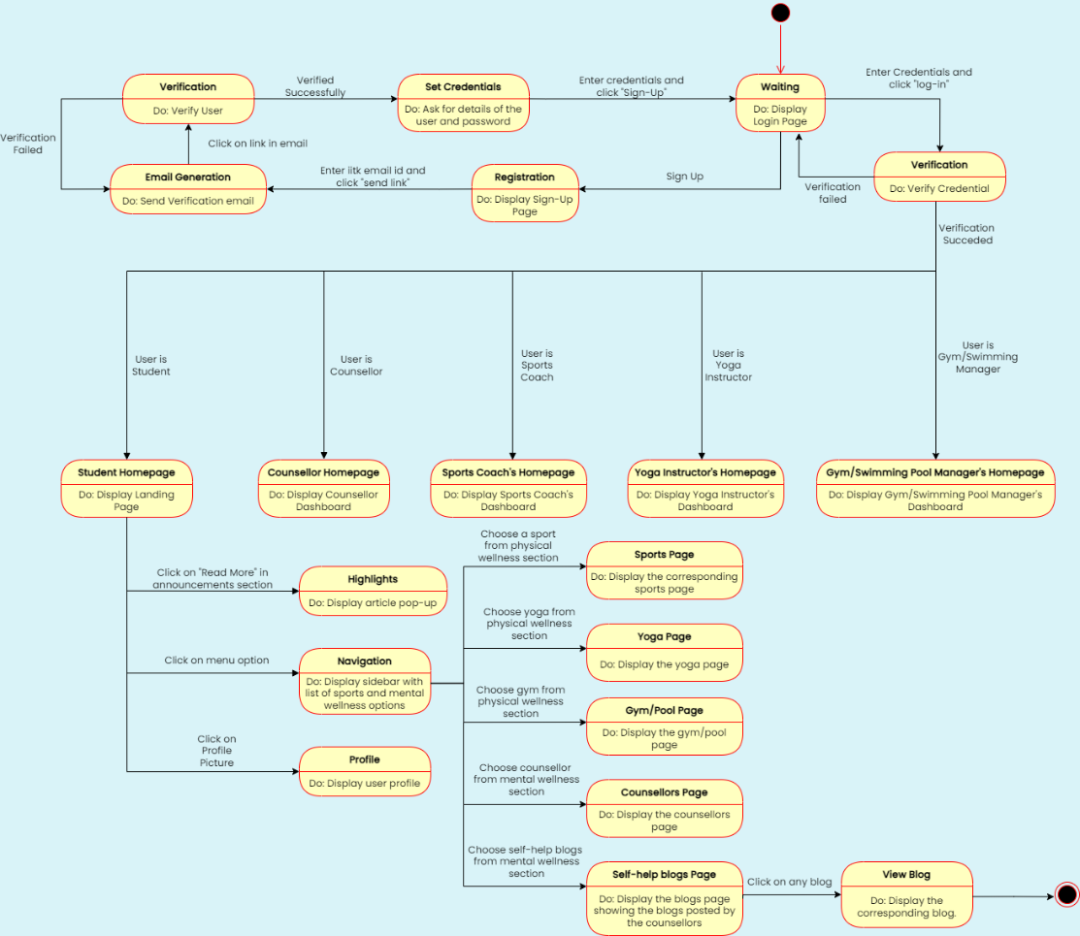

* + 1. 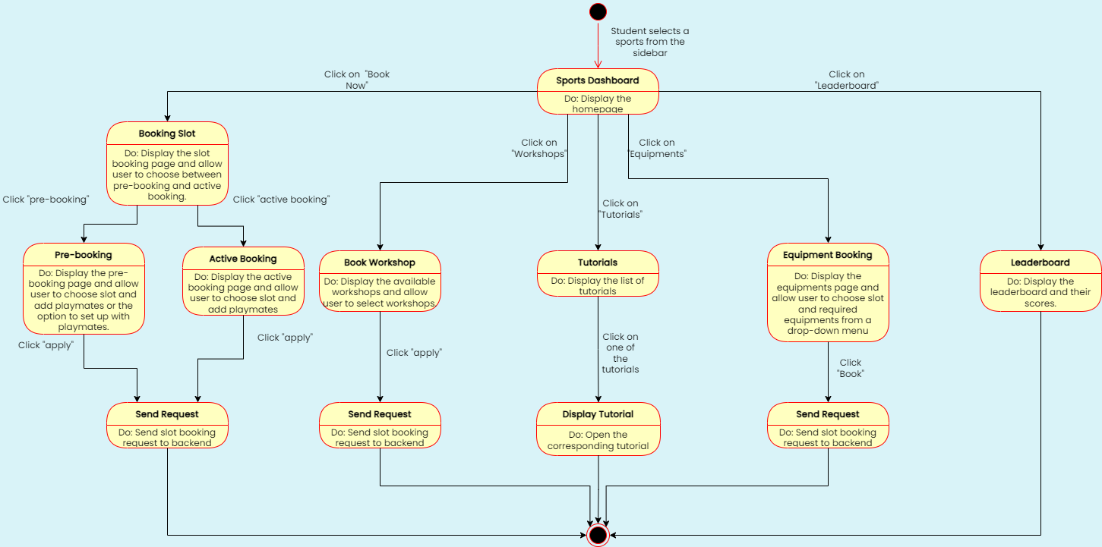**Availing Sports Services**
    2. **Sports Coach**

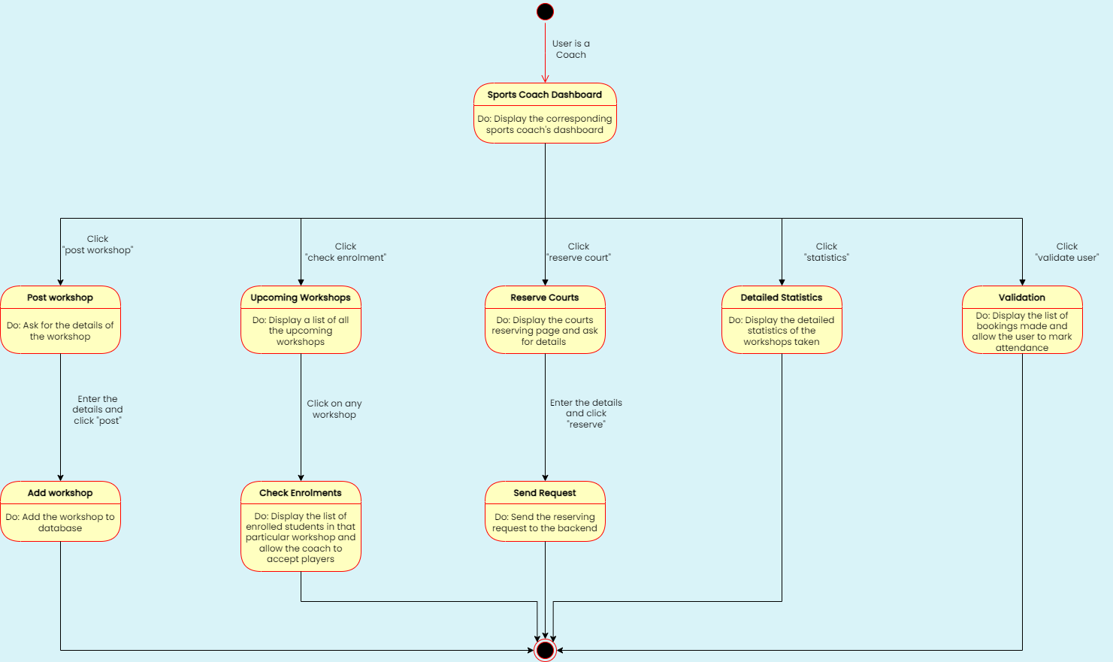

* + 1. **Gym/Swimming Instructor**

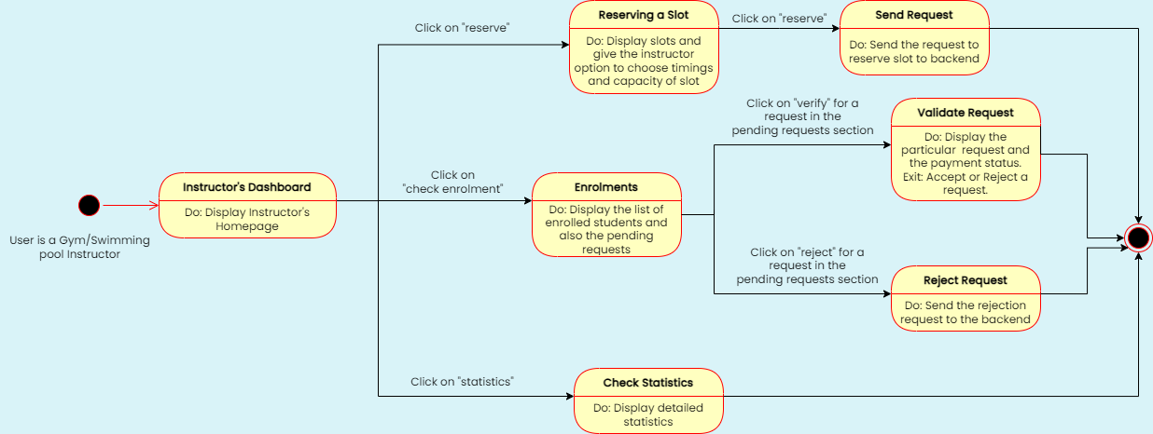

* + 1. **Availing Gym Services**

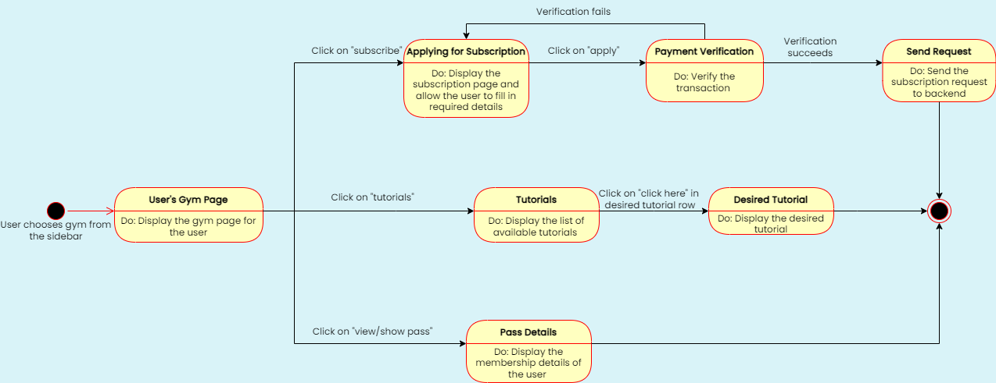

* + 1. **Availing Counselling Services**

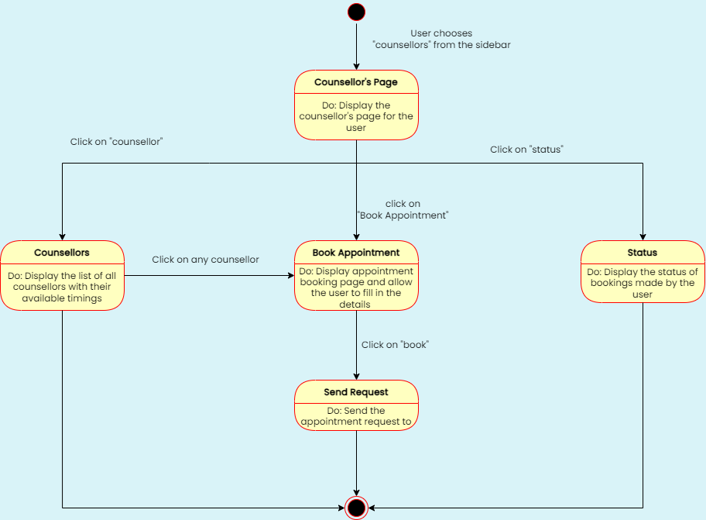

* + 1. **Counsellor**

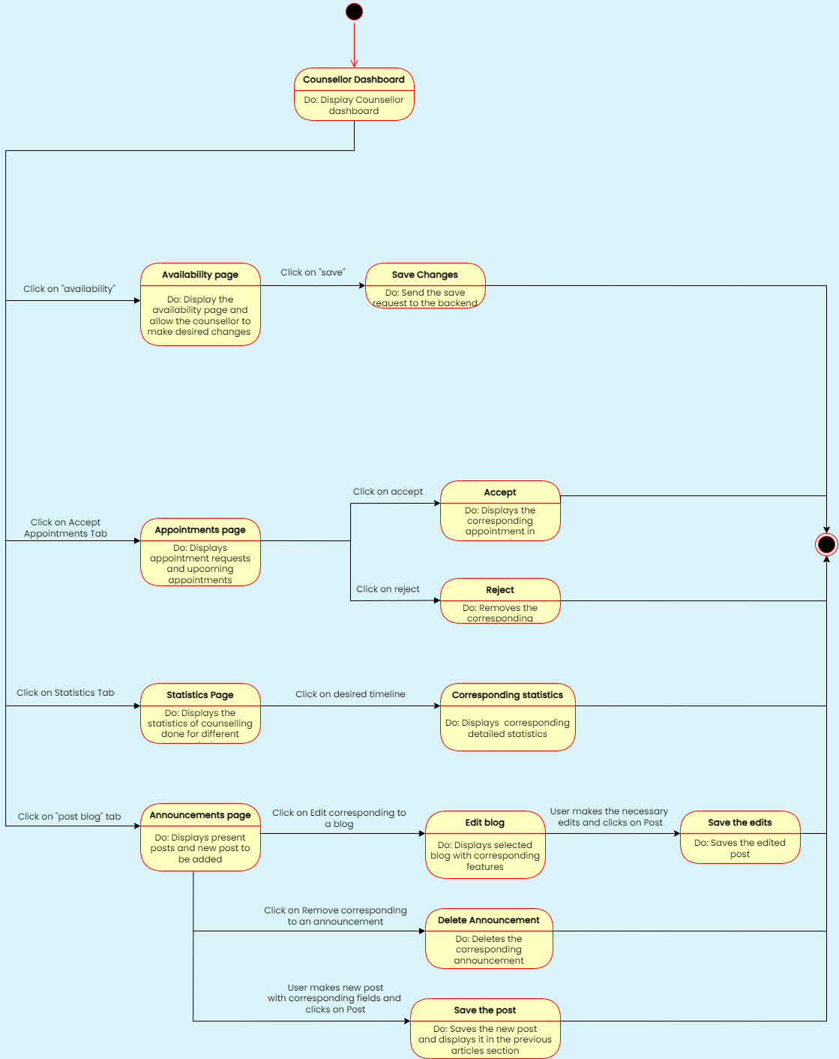

* + 1. **Yoga Instructor**

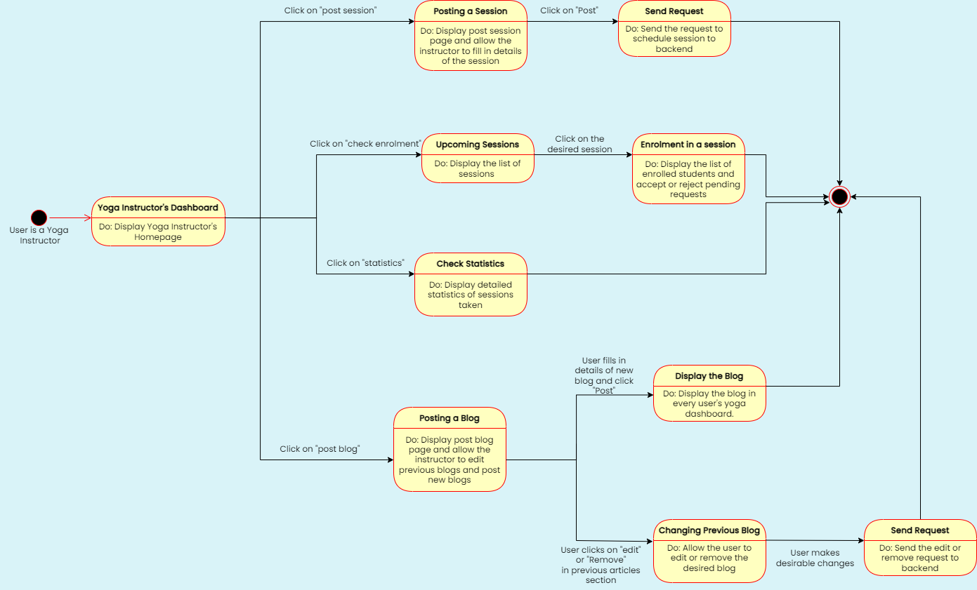

**3.4.9 Availing Yoga Services**

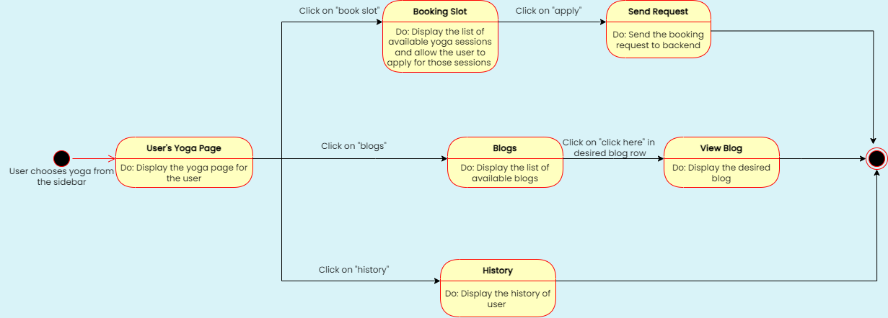

# Project Plan





Appendix A - Group Log

|  |  |  |  |
| --- | --- | --- | --- |
| **Date** | **Timings** | **Duration** | **Minutes** |
| 30 Jan | 21:00 – 23:30 | 2hrs 30min | * Discussion regarding UI design and work distribution corresponding to it. |
| 1 Feb | 22:00 – 00:00 | 2hrs | * Planning of Architecture design |
| 3 Feb | 18:30 – 19:00 | 30min | * Discussion regarding databases with mentor TA Mr. Sarthak Neema. |
| 3 Feb | 19:00 – 01:00 | 6hrs | * Modified the ideas of databases based on our discussion with our mentor TA. * Planning of databases and Class diagrams. * We decided on a central database for authentication * We will be maintaining a second database for bookings, memberships etc. * A third database for content. * Work on class diagrams and sequence diagrams started. |
| 6 Feb | 17:00 – 19:30 | 2hrs 30min | * Completion of class diagrams and sequence diagrams. * Completion of UI. |
| 9 Feb | 21:00 – 00:00 | 3hrs | * Proof reading of the document. |